Cartography of the moral situation in AI systems

An information-based framework

The use of the informational approach marks a significant shift in AI-ethics. In the past, ethical analysis has primarily focused on the pipeline or life-cycle of an AI system. However, these approaches are limited as they concentrate on specific technological system elements, disregarding the morally significant macro-structures in which the systems operate. This results in technology-specific approaches that are difficult to generalize. In contrast, the informational approach examines AI systems at a more conceptual, yet morally relevant level where ethical choices and actions occur, and ethical consequences emerge. Moreover, this framework analyses each stage of the informational transformation process as sequences of autonomous moral situations.

In the upcoming chapter, we present the approach methodology for the study (2), outlining its key components: the focus of analysis, namely the scenario created by the AI system (2.1), the mapping of ethical scenarios using the OOP – Oriented Object Programming (2.2), and the ethical aspects that determine the potential occurrence of chance of ethical risk (namely the augmentation of hazardous elements, wherein the increase in ethically questionable factors potentially leads to a greater likelihood of harm or adverse outcomes) within the moral situation (2.3).

Methodology

Our approach focuses on identifying the fundamental structures within a moral scenario and inferring that the introduction or augmentation of hazardous elements can elevate the associated risk factors. By understanding the underlying moral framework and recognizing how the presence of additional hazards can impact the situation, we aim to gain insights into the potential ethical implications and consequences.

We adopt the “informational approach” a meta-ethical theory that provides a framework for examining moral concepts and situations. In accordance with this viewpoint, a moral situation is a specific context in space and time within the “infosphere” where moral actions take place (Floridi, 2013b, p. 108).

An assessment can be done on how various factors interact and influence the moral landscape. This allows to determine the potential risks and hazards that may arise when introducing new elements or increasing the intensity of existing ones. The augmentation of hazards introduces a higher degree of uncertainty and potential harm, which necessitates careful consideration and ethical evaluation.

Taking this approach enables us to proactively identify and address the ethical dimensions involved, ultimately assisting in decision-making processes and guiding the development of responsible AI systems. By understanding the impact of hazard augmentation on risk factors within the moral scenario, we can strive to minimise harm, enhance safety, and promote ethical practices.

Practically, when dealing with agent/recipient interactions and acknowledging the presence of moral situations, the approach involves:
1) Identifying undetected moral situations that are not neutral;
2) Assessing their relevance, discarding negligible ones and mapping the relevant ones;
3) Discussing mapped moral situations with the team for better understanding; 4) Answering a questionnaire for each moral situation to identify risk elements that can impact the level of ethical risk;
5) Generating a radar chart based on a predefined axiological table to indicate critical points and the level of risk.

Finally, it should be noted that the project’s limitation lies in the axiological table, which should undergo testing and improvement by an internal ethics team, making it currently “indicative” for process comprehension.

The moral situation

In general, a situation refers to a set of circumstances or conditions in which something or someone exists or operates. And we refer to a moral situation whenever the ethical impact of the situation has to be taken into account. This definition can be logically inverted by imagining that a situation always has a moral charge, yet in many cases the moral charge is negligible (in this case we can speak of a state of inertia). The main objective is then to understand when the moral charge moves from a state of neutrality to a state of relevance (whether positive/good or negative/evil as represented in Figure 1). The goal is to identify this moral threshold.

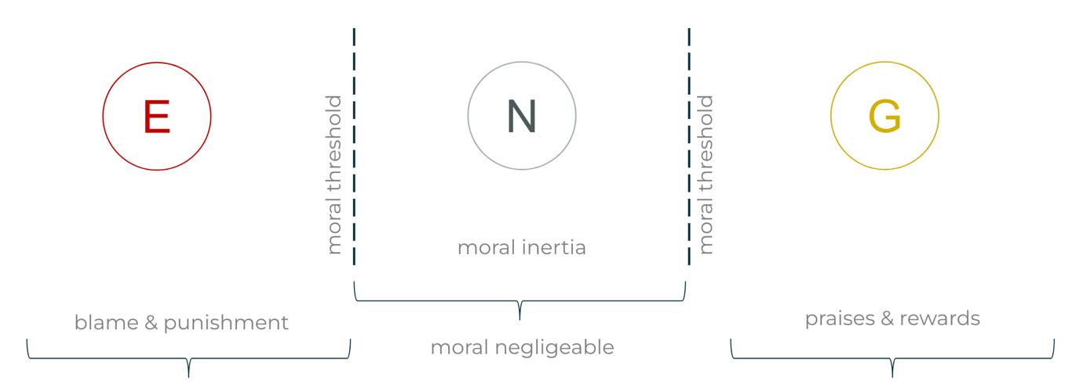
Figure 1 -The moral threshold – E: Evil, N : Neutral, G : Good

A moral threshold, however, is not a clear and visible demarcation system. The threshold is visible through the observers’ ability to bring it to the surface. In order to make the moral threshold emerge, we use the moral situation model introduced by Floridi (2013, p. 103-109), on which we analyse each element individually to arrive at highlighting every possible ethical issue.

According to Floridi, a moral action understood as a dynamic system can be modelled in terms of an information system by using the object-oriented programming methodology.
As shown in Figure 2, a moral situation is then composed of
(1) A = the moral agent
(2) P = the moral patient
(3) M = the moral action, constructed as an interactive information process
(4) shell = the moral agent’s personal world of information
(5) factual information = information about the moral situation
(6) envelope = the moral situation
(7) infosphere = the general environment

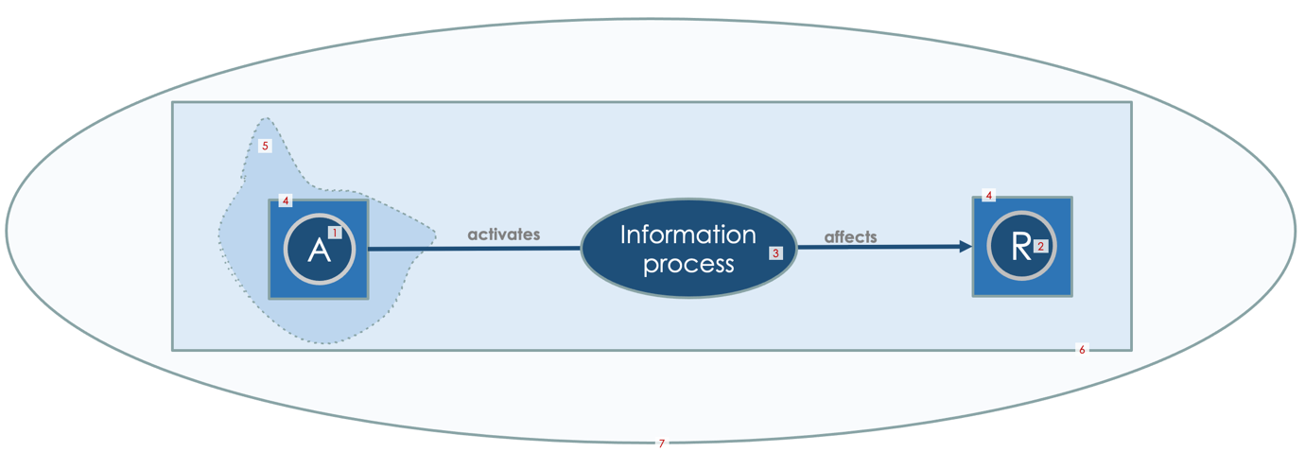
Figure 2 - The moral situation modelled using OOP

An agent (1) activates an information process (3) thanks to the information it has at its disposal. This information is only a representation of the world and constitutes the agent’s information shell (4). The shell is therefore only a reduction of reality that may be influenced by the factual information about the moral situation (5) that the agent has. The information process influences a receiver or patient (2) and the relative personal world of information, the shell (4). The receiver (2) is understood as an individual or group of individuals or, in general, an information entity. This is the envelope (6) within which the moral situation develops, which in turn is located in the information environment surrounding us: the infosphere (7).

The method presented is based on the assessment of moral situations arising in a process of production or distribution of an AI-enhanced digital artefact.
Once the moral situation has been identified, the ethical dimensions for each element of it are analysed. The weight of each dimension of a situation should be analysed and improved by a specific ethics committee, but in this case the methodology stops before the dimension tuning phase. As a matter of fact, the method presented below is necessary to focus on the critical ethical dimensions in order to allocate the right amount of resources to resolve ethical trade-offs. The methodology is presented in detail below.

The cartography
The moral situation appears whenever an agent interacts with a receiver. Theoretically, the level of granularity should be defined by all relevant stakeholders, however, for practical reasons it can be defined by the stakeholders involved during the mapping process. This limitation must be appropriately documented.

As shown in Figure 3, the cartography can be developed at the production level (from data collection to the output distribution) and at the interaction level (when the system is understood as an informational process between informational entities internal or external to the production process). In the second case, the analysis shifts more to Ethical Foresight Analysis (EFA) and a stronger interaction with the company’s business ethics is often required.

During the production process, following an informational approach, the system can be divided into macro areas through which data become knowledge (DIK process of knowledge visualization, based on Masud et al., (2010)).

In the first phase, data has no meaning, so we have no information. Data are interpreted diaphorically as elements in which there is a lack of uniformity.
We started from the definition of datum as “x being distinct from y, where x and y are two uninterpreted variables and the relation of ‘being distinct’, as well as the domain, are left open to further interpretation”.
This means that the definition of “datum” is used as a difference (in fact “diaphora” is “difference” in ancient Greek) in three main ways:
- data as a lack of uniformity in the real world (i.e. a red light against a dark background)
- data as a lack of uniformity between (the perception of) at least two physical states of a system or signals (i.e. a higher or lower charge in a battery)
- data as a lack of uniformity between two symbols (i.e. the letters B and P in the Latin alphabet).

In the second phase, there is a process of semantization in which the aim is to achieve a body of information consisting of well-formed, meaningful and veridical data. Finally, when information becomes accessible, knowledge can be built in terms of explanations explanations or descriptions that give meaning to the semantic information that is available.

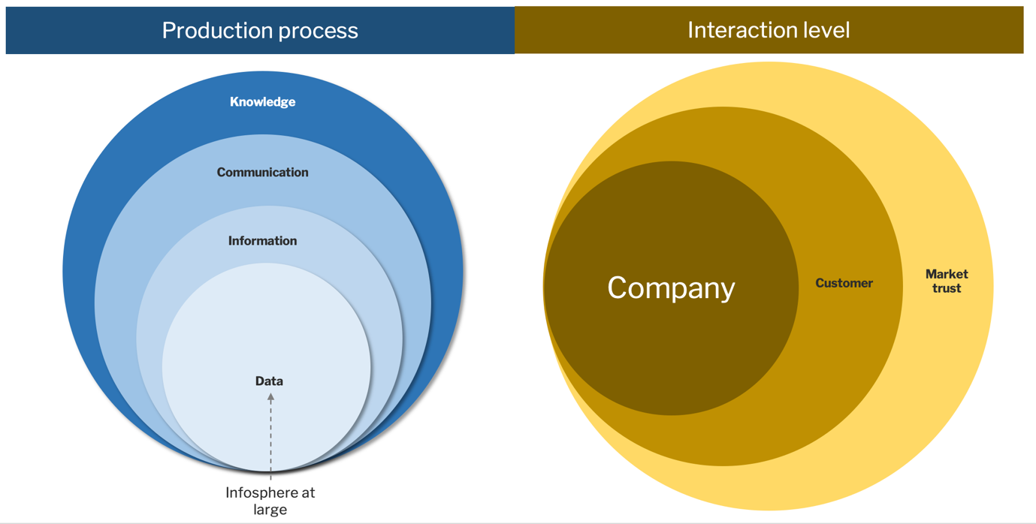
Figure 3- Level of granularity where the moral situation can arise

The ethical dimensions

Thanks to this approach, we can formulate questions for risk identification that consider each individual element of the moral situation, as shown in Figure 4: agent (distribution or density of agents; quantity of implementable actions by the agent; semantic level of the agent; semantic decay of the agent), receiver (distribution or density of receivers; time for the receiver to act; relevance aka significant harms from the receiver; semantic variability of receivers; semantic level of the receiver; semantic decay of the receiver), the relation between the agent and the receiver (semantic plausibility of the agent), the information process (time for the mediator to act; anomaly type detection; anomaly detection frequency; semantic level of the mediator; remediation mechanisms), and the environment (density of variables in the environment; level of accessibility of the environment; level of determination in the environment; level of stationarity of the environment; quantity of actions in the environment).

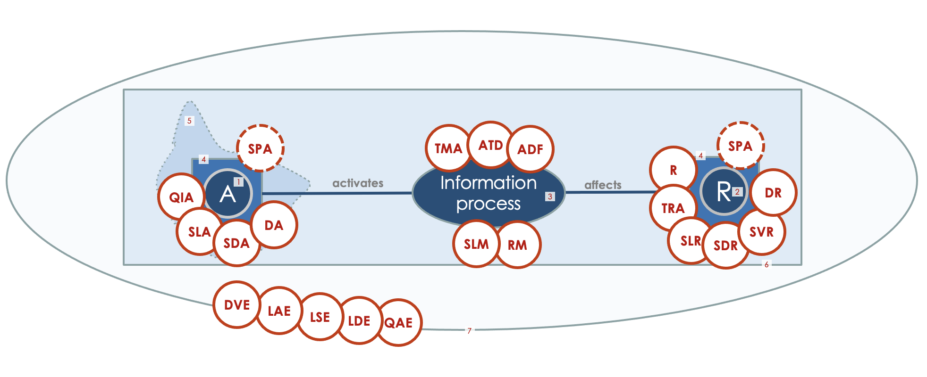
Figure 4 - Ethical dimensions on a moral situation

Each dimension corresponds to a question that enhances the ethical reasoning on those elements, as shown in Table 1. Aggregating the answers to these questions makes it possible to quickly identify risk elements and provide an interface for ethical risk assessment.

Table 1 - Ethical dimensions
Acr | Title | Question | informational entity
DA | Density of Agents (distribution) | How many possible agents can generate actions simultaneously? | agent
QIA | Quantity of Implementable Actions | How many actions can the agent implement | agent
SDA | Semantic Decay of the Agent | What impact the model has on the agent’s semantic capital? | agent
SLA | Semantic Level of the Agent | What is the nature of the agent? (from expert to AI) | agent
SPA | Semantic Plausibility of the Agent | To what extent can an artificial agent be perceived as human? (Imitation game) | agent/receiver
SDR | Semantic Decay of the Receiver | What impact the model has on the receiver’s semantic capital? | receiver
SVR | Semantic Variability of Receivers | How different is their semantic ability of the receivers? | receiver
TRA | Time for the Receiver to Act | Will the receiver have enough time to intervene | receiver
R | Relevance (aka significant harms) | How much this decision impacts the receiver’s quality of life? | receiver
SLR | Semantic Level of the Receiver | Does the recipient of the action have the tools to counteract a decision (intellectually and/or financially)? | receiver
DR | Density of Receivers (distribution) | How many possible receivers can an action affect? | receiver
TMA | Time for the Mediator to Act | Will the mediator have enough time to intervene? | information process
ATD | Anomaly Type Detection | Are there monitoring systems to identify all types of anomalies? | information process
ADF | Anomaly Detection Frequency | How frequent is the process of identifying anomalies? | information process
SLM | Semantic Level of the Mediator | Is the mediator in the process capable of identifying or resolving anomalies? (human in the loop/Mediator=expert, call centre, AI) | information process
RM | Remediation Mechanisms | Is there an easily accessible mechanism to correct a problem? | information process
DVE | Density of Variables in the Environment | How many (external / non identified) variables can change the information process? | environment
LAE | Level of Accessibility of the Environment | Is the environment accessible to the agent? | environment
LDE | Level of Determination in the Environment | Are the effects of an action on the environment known? | environment
LES | Level of Stationarity of the Environment | Are the changes in the environment in the agent control? | environment
QAE | Quantity of Actions in the Environment | Can the environment limit the number of actions? | environment

The dimensions may be used as an tool for ethical reasoning composed structured in four stages.
The initial step involves utilizing open-ended questions to discover potential risks associated with a given AI application. These risks are categorized into various dimensions that correspond to the moral aspects of the situation.
The second aspect is an axiological analysis, which uses a 5-point Likert scale to assign numerical values to each dimension. This process is particularly delicate because it has to attempt to represent the shared ethical values of the company as faithfully as possible on a continuous numerical scale. The committee dealing with this process is multidisciplinary and composed of specialists (ethicists, anthropologists, social lawyers, data scientists, economists, etc.) and other stakeholders (customers, associations, etc.). However, these numerical values are not fixed and can be adjusted within the organization to better align with the specific application being evaluated. The Likert scale uses simple, easy-to-understand labelling for developers.
The third component entails performing a risk assessment by selecting the appropriate Likert option for each dimension to determine the overall risk level.
Lastly, a radar chart is employed to visually represent the risk level in relation to both the overall and individual dimension risks, promoting a balanced assessment that incorporates both holistic and analytical perspectives.

This study leveraged the power of cartography to visually present the ethical risk levels associated with two unique use-cases: Opinion Mining (Renault) and Scene Understanding (Valeo). We sought to investigate different moral situations that are inevitably tied to these use-cases, and used radar charts to numerically express the varying ethical risk levels associated with each situation.

We must emphasize, however, that the moral situations explored in the context of Opinion Mining and Scene Understanding were inherently different. They each presented unique challenges and considerations, making it impossible to draw direct comparisons between them. Instead, our focus was to underscore the nuanced ethical dimensions of each situation, fostering a deeper understanding of the multifaceted nature of ethical considerations.

Moreover, the ethical dimensions associated with each moral situation be adapted, extended, and refined according to the specific characteristics and requirements of the use-cases and moral situations. This flexibility allows for a more tailored approach to ethical risk assessment, ensuring that our model can capture the most salient ethical concerns in different contexts.

In sum, our cartographic approach offers a tool for visually representing and understanding ethical risk levels. It provides a platform for nuanced ethical analysis, and allows for the adaptation and enrichment of ethical dimensions based on the specificities of each use-case. While further research is needed to explore the full potential of this approach, our study marks a step in understanding and managing ethical risks.

References
AI Act. 2021. Proposal for a Regulation of the European Parliament and of the Council Laying Down Harmonised Rules on Artificial Intelligence (Artificial Intelligence Act) and Amending Certain Union Legislative Acts. https://eur-lex.europa.eu/legal-content/EN/TXT/?uri=celex%3A52021PC0206
AI HLEG. (2020). Assessment List for Trustworthy Artificial Intelligence (ALTAI). https://ec.europa.eu/newsroom/dae/document.cfm?doc_id=68342
Aven, T.; Ben-Haim, Y.; Andersen, H. B.; Cox, T.; Droguett, E. L.; Greenberg, M.; Guikema, S.; Kröger, W.; Renn, O.; Thompson, K. M.; and Zio, E. 2018. Society for Risk Analysis Glossary. https://www.sra.org/wp-content/uploads/2020/04/SRA-Glossary-FINAL.pdf
Devillers, L. (2021). Human-Robot Interactions and Affective Computing: The Ethical Implications. In Robotics, AI, and Humanity (pp. 205–211). Springer.
Devillers, L., Fogelman-Soulié, F., & Baeza-Yates, R. (2021). AI & Human Values. In B. Braunschweig & M. Ghallab (Eds.), Reflections on Artificial Intelligence for Humanity. Lecture Notes in Computer Science (Vol. 12600, pp. 76–89). Springer, Cham. https://doi.org/10.1007/978-3-030-69128-8_6
EY. (2021). A survey of AI Risk Assessment Methodologies. https://www.trilateralresearch.com/wp-content/uploads/2022/01/A-survey-of-AI-Risk-Assessment-Methodologies-full-report.pdf
Floridi, L. 2013. The Ethics of Information. Oxford University Press.
Floridi, L. and Sanders, J. W. 2008. The method of levels of abstraction. In Yearbook of the Artificial. Nature, Culture and Technology. Models in Contemporary Sciences, edited by M. Negrotti, 177-220. Peter Lang.
Ganapini, M., & Panai, E. (2023). An Audit Framework for Adopting AI-Nudging on Children. Notre Dame-IBM Tech Ethics Lab
ISO/IEC. forthcoming. ISO/IEC DIS 23894 - Information technology - Artificial intelligence - Guidance on risk management. https://www.iso.org/standard/77304.html
McGregor, S. 2021. Preventing Repeated Real World AI Failures by Cataloging Incidents: The AI Incident Database. In Proceedings of the AAAI Conference on Artificial Intelligence, 35(17), Article 17. https://doi.org/10.1609/aaai.v35i17.17817
Microsoft. 2022. Types of harm - Azure Application Architecture Guide. https://learn.microsoft.com/en-us/azure/architecture/guide/responsible-innovation/harms-modeling/type-of-harm
NIST. 2022. AI Risk Management Framework. https://www.nist.gov/itl/ai-risk-management-framework
Panai, E. and Light, R. Forthcoming. Raising the Ethical Voice of the Periphery in the Construction of AI Ethics Frameworks. Preprint.
Tartaro, A., Panai, E. and Cocchiaro, Z. Forthcoming. Risk Assessment Using Ethical Dimensions. Preprint.

In the philosophical tradition, the receiver can also be called the patient, but for communication purposes we prefer to identify him/her as the receiver.
Floridi, L. (2010). Information. A Very Short Introduction. Oxford University Press.

