Renault

The case study examined for the Renault group, concerns artificial intelligence systems used in the support of the classification of Renault customers’ comments or opinions with the aim of tracing insight information back to the departments concerned. The aim is to direct the strategic choices of departments in order to improve the final quality of the product and strengthen the relationship of trust with customers.

The study conducted for Renault is based on the analysis of moral situations to understand what kind of moral issues this system can raise.

Initially we will introduce the method based on the moral situation, the spaces (phases) where the moral situation raise and finally we will analyse each phase as elements of a moral situation.

The use case and mapping of spaces for RENAULT

Introduction

The study done for Renault is based on the analysis of moral situations arising in the production pipeline (from data collection to the strategic choice of departments). For this study, there was insufficient data for an analysis of trust in the post-production phase, i.e. in the relationship between salespeople and customers, between after-sales service and customers, and globally between the brand and market trust, as shown in .

In the production pipeline, the various steps were developed following the classical Data Information Knowledge structure. A communication layer was added to this scheme, which was considered important to assess the semantic decay of the message between one step and another.

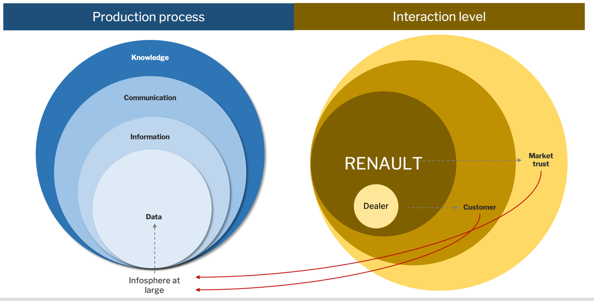
Figure 5 - Level of granularity related to this use case

Limitations
The level of granularity needed emerged from the discussion with Renault and was refined during the divisional meetings. This is an experimental top-down use case, so not all stakeholders in the process were present in defining the scope of action and the level of granularity needed. The study therefore entails an epistemological limitation that should be bridged in the case of real application.

The levels of cartography

This case study considers only the stages of the production process, as these are currently the only ones about which factual semantic information can be obtained at this stade.

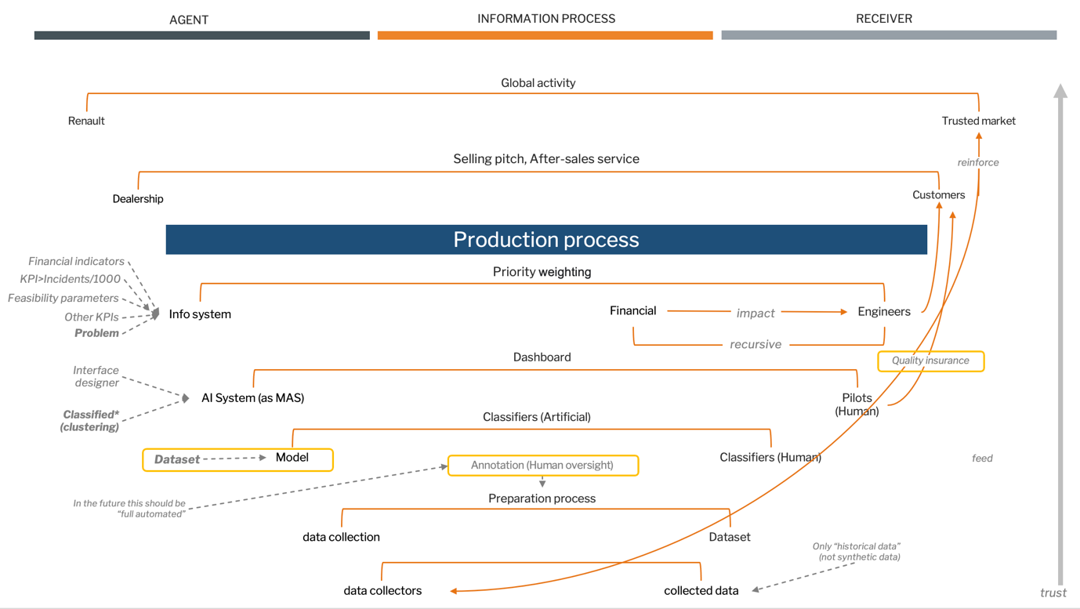
Figure 6 - Detected moral situations

During the process, Renault was asked to technically describe the various stages of the process and for each stage the moral situations on which to ask questions were identified together. This resulted in the following list of moral situations, as shown in Figure 4:
- DATA COLLECTION: Web – DCW
- DATA COLLECTION: Survey benchmarked – DCSB
- DATA COLLECTION: Internal Survey Seller – DCISS
- DATA COLLECTION: Internal Survey SAV – DCISSAV
- DATA ANNOTATION: Human & Now – DAHN
- DATA ANNOTATION: Hybrid & Future – DAHF
- DATA ANNOTATION: AI & Future – DAAIF
- DATA FILTERING – DFI
- SUGGESTION AI SYSTEM – SAI
- DASHBOARD – DAS
- STRATEGIC KNOWLEDGE – STK

In the following sections, the moral situations are described one by one.

DATA COLLECTION

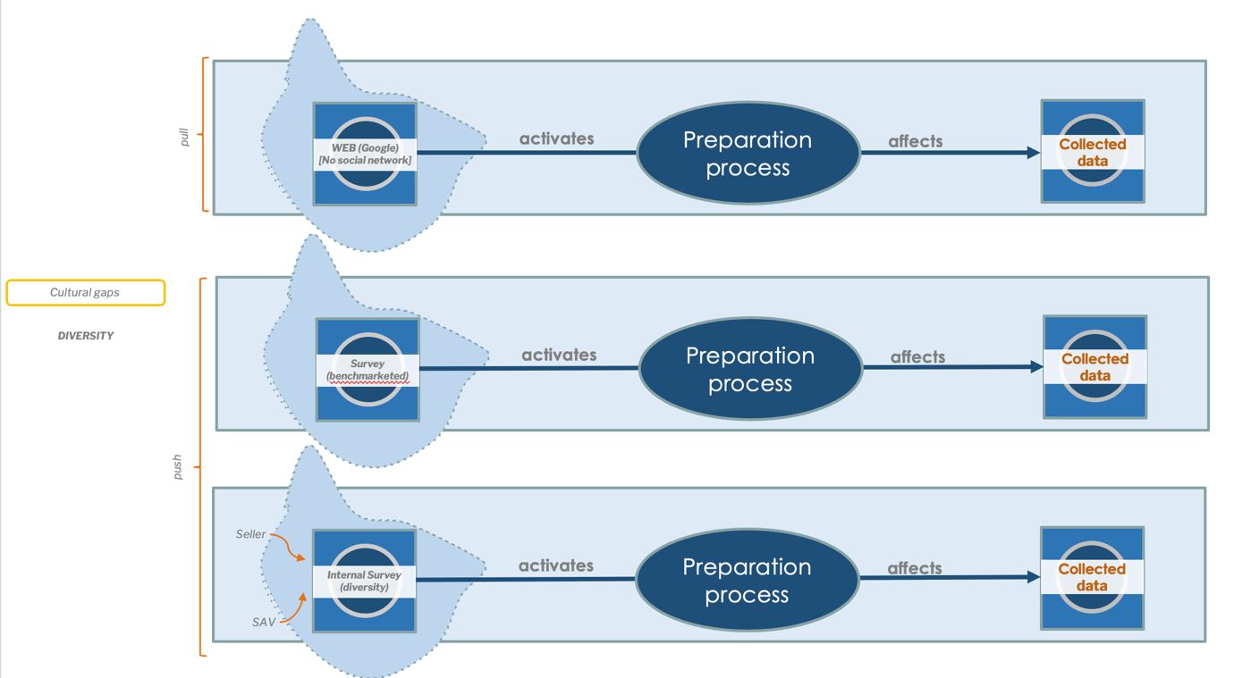

The first step concerns data collection. In the description received, two groups can be identified which collect data. The first in pull mode, in which data is searched on the network (currently only in Google comments and not yet in social networks); the second in push mode, in which data is requested directly from customers.
The moral situations generated during data collection have the receiver and the data collected (understood as the informational entity receiving the action). All collected data is historical, so no synthetic data is currently used to train the machines.

The Pull mode generates a moral situation (DATA COLLECTION: Web - DCW) composed of the agents involved in the collection processes (e.g. webscrapping, etc.).

The Push mode generates three distinct moral situations. One moral situation where the agent is an external survey company (DATA COLLECTION: Survey benchmarked - DCSB); and two moral situations where the survey is internal, once carried out through seller satisfaction forms (DATA COLLECTION: Internal Survey Seller - DCISS) and once carried out by the after-sales service (DATA COLLECTION: Internal Survey SAV - DCISSAV).

Elements highlighted during the analysis of this moral situation
- the possibility of a cognitive, perceptive or cultural gap in case the agents are human or hybrid (DCSB, DCISS, DCISSAV).
- data collection methods affect the final quality of the data collected
- lack of diversity in human collection groups can be a risk factor

Mitigation strategies
Adapted mitigation strategies for possible ethical risks include:

      - Ongoing training and education. Provide continuous training and education programs to bridge cognitive and perceptive gaps, ensuring that agents, whether human or hybrid, have the necessary knowledge and skills to understand and interpret diverse perspectives.
      - Cultural sensitivity and diversity awareness. Foster a culture of inclusivity, diversity, and cultural sensitivity to minimise the impact of cultural gaps. Encourage open communication and promote diversity in teams to enhance cross-cultural understanding.
      - Diverse recruitment and inclusive hiring practices. Actively promote diversity and inclusion when assembling human collection groups. Implement inclusive hiring practices to ensure representation from diverse backgrounds, cultures, and perspectives.
      - Collaboration with diverse communities. Engage with diverse communities to foster participation and involvement in the data collection process. This helps to capture a broader range of experiences and reduce the risk of biased or limited perspectives.

Assessments
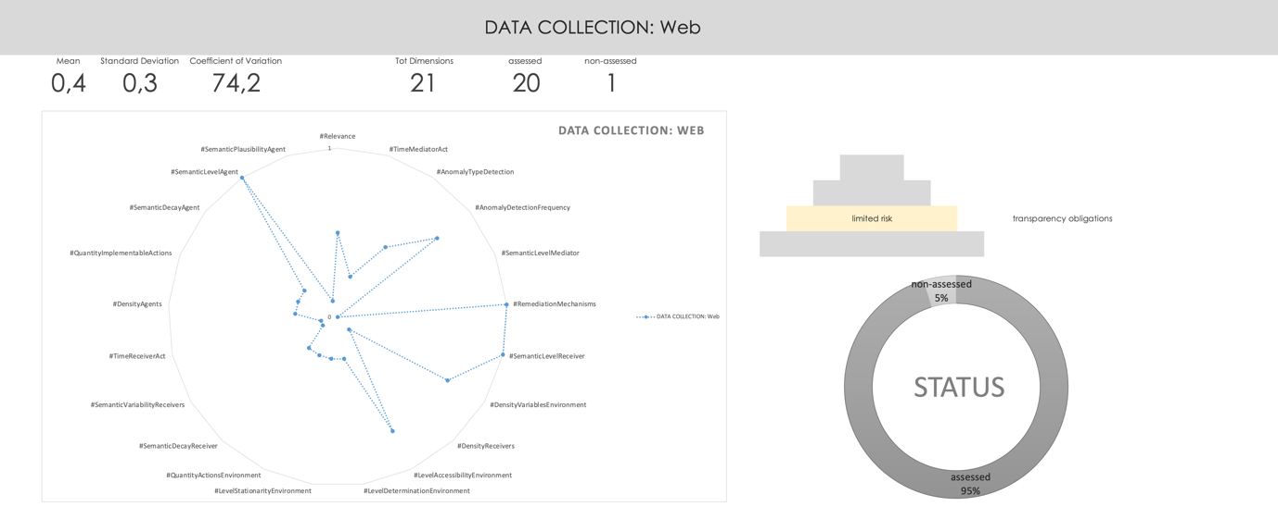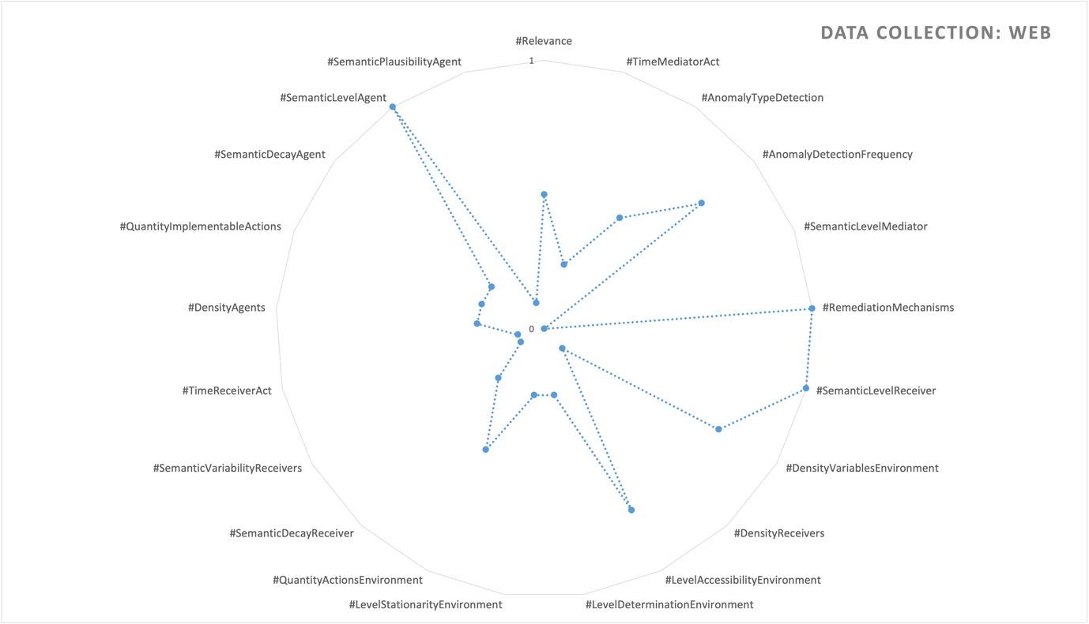

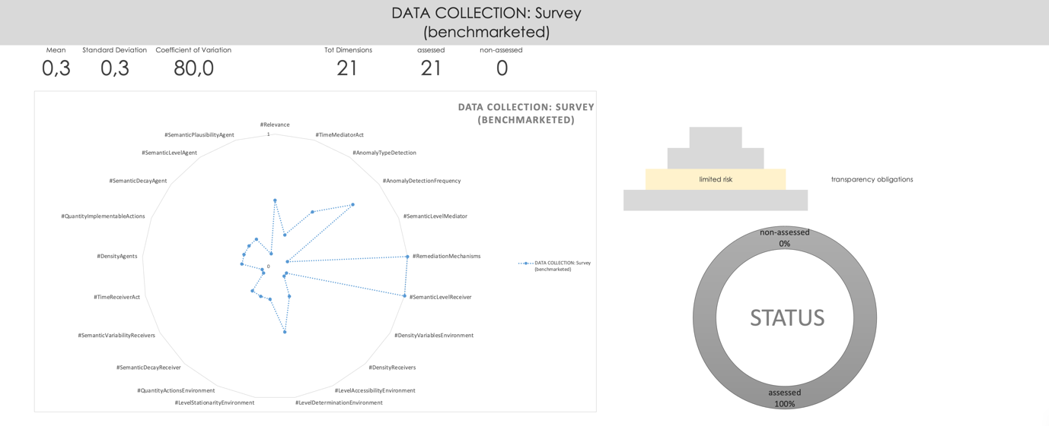
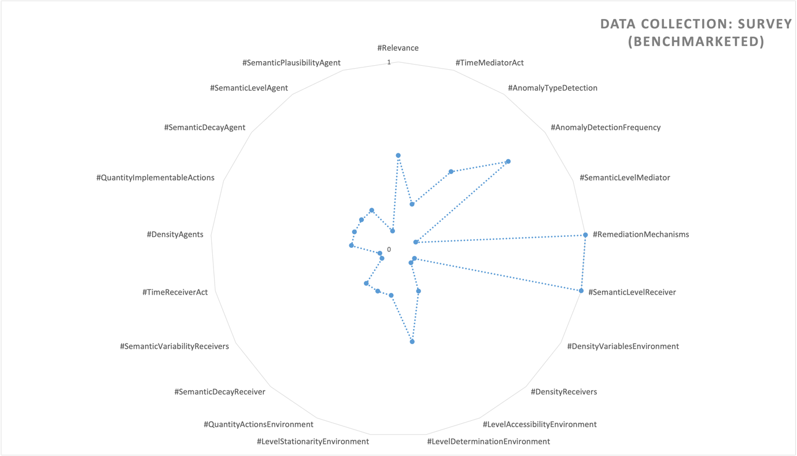

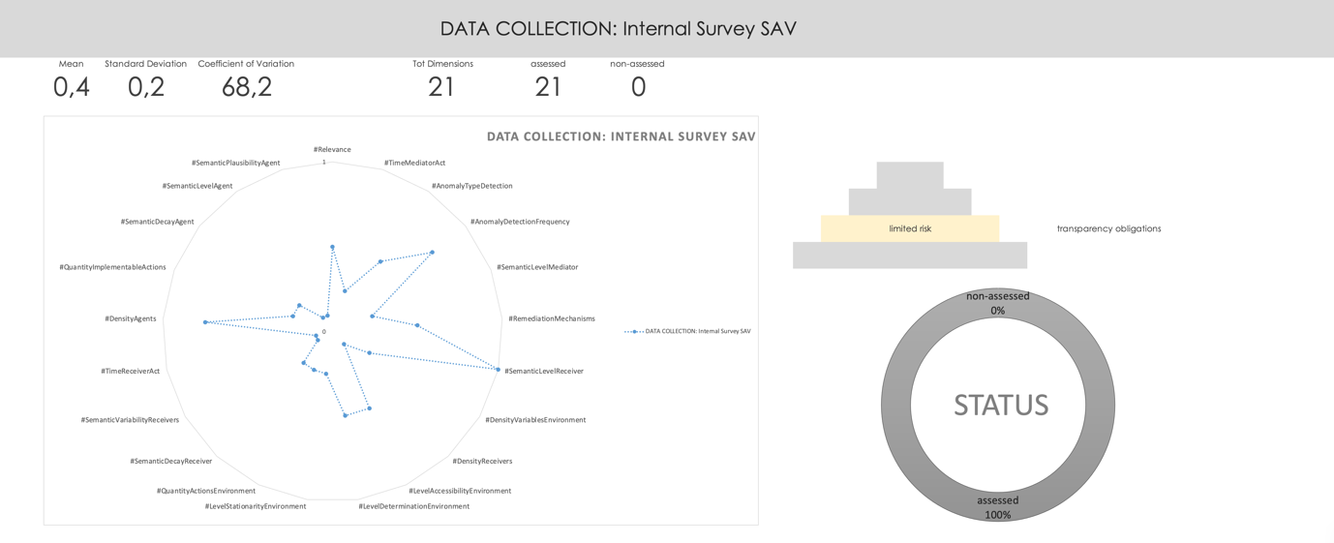
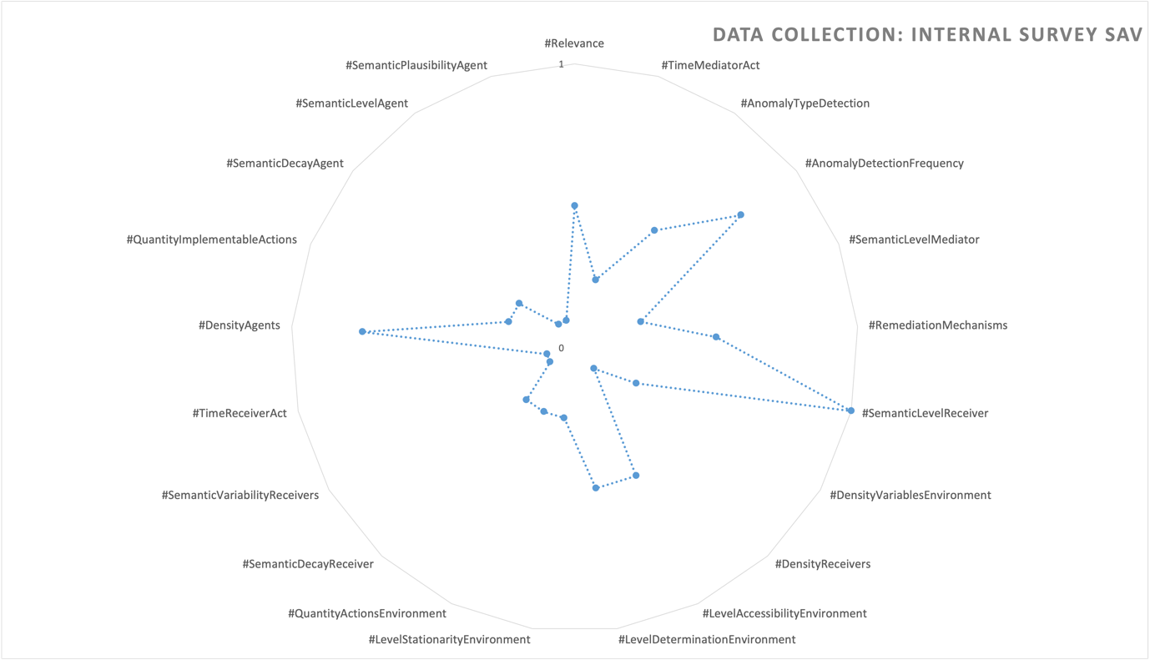

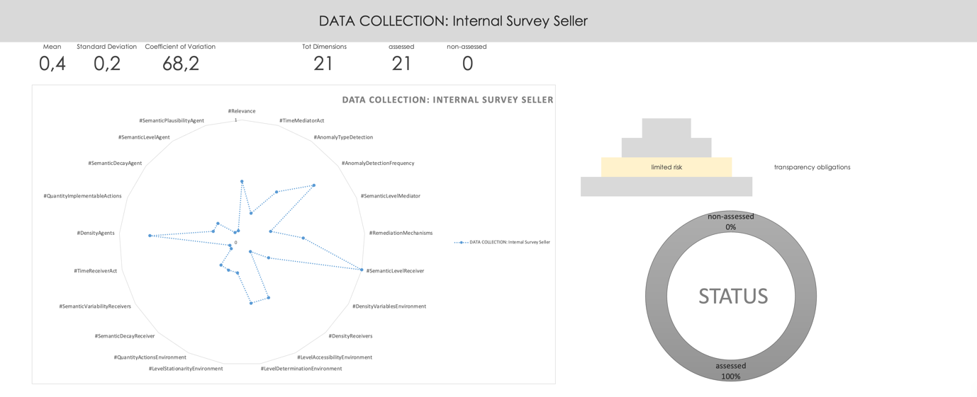

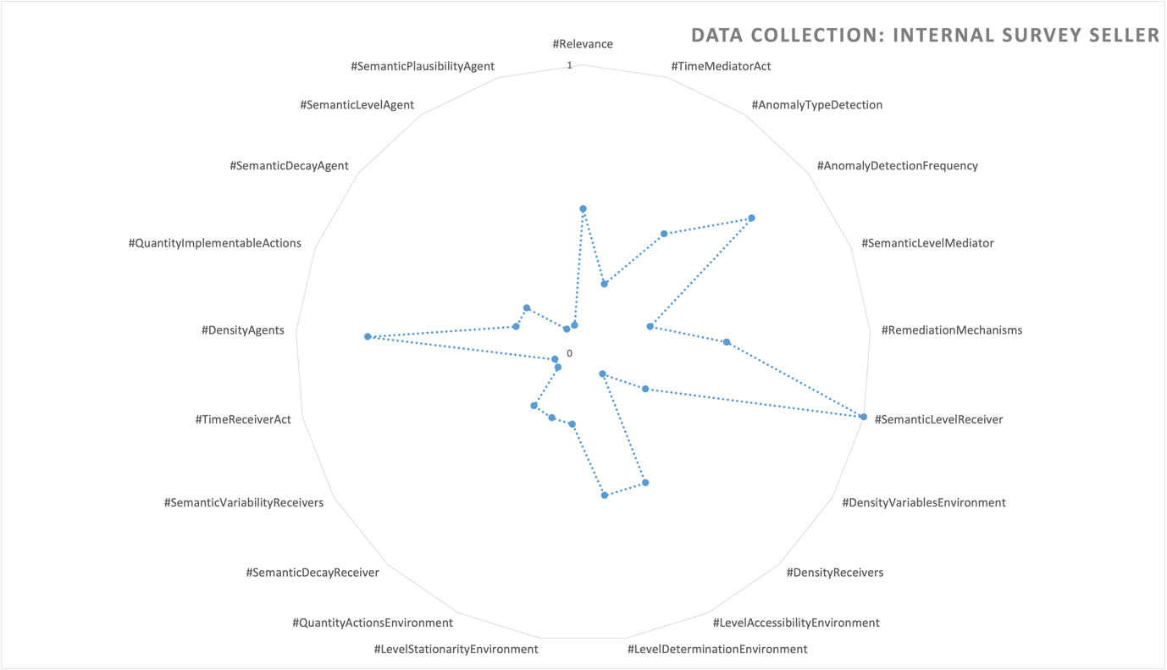

DATA ANNOTATION
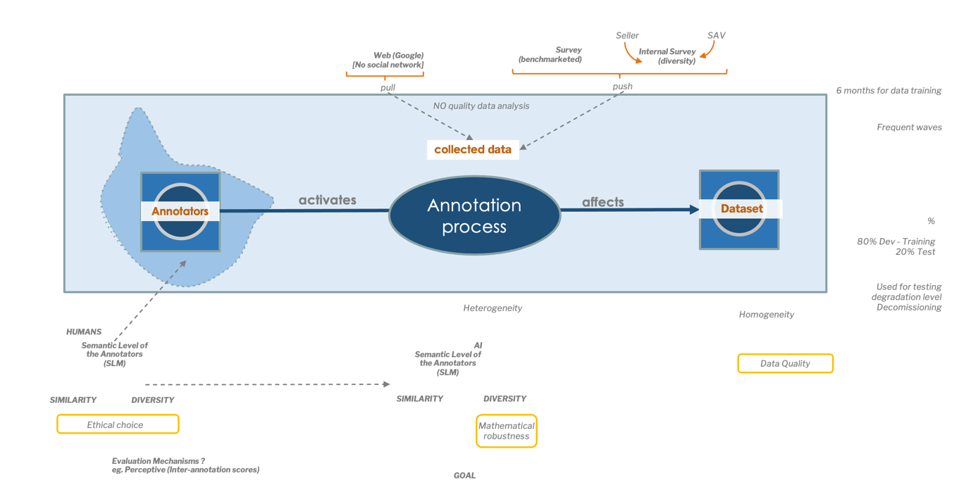
The second phase concerns data annotation. In the description received, some annotators act on the data collection to finalise the dataset that will be used in the learning process.

The agents that activate the annotation processes in a moral situation (DATA ANNOTATION: Human & Now - DAHN) have an impact on the dataset.

Currently the process is done by humans but in the future the process could be done entirely by AI systems. Two new moral situations could then be generated, the first in the intermediate phase in which a hybrid agency state between humans and AI will be maintained (DATA ANNOTATION: Hybrid & Future - DAHF), and the second in the final phase in which the agents will be entirely artificial (DATA ANNOTATION: AI & Future - DAAIF).
We will consider these two possibilities in order to point out some possible avenues for Ethical Foresight Analysis.

At present, the annotation capacity (i.e. the semantic capacity of the agents in the annotation process) is crucial to guarantee the quality of the final dataset. Given the difference in data sources, this phase is necessary to bring the state of heterogeneity of the collected data to a state of homogeneity of the final dataset.
The dataset will be used according to the Pareto principle; approximately 80% for development and training and 20% for testing.

Elements highlighted during the analysis of this moral situation
- The composition of the annotators and the result of the choice of an ethical instance should be traced and documented
- on the whole, a higher level of diversity of the annotators may decrease the risks of conflict or misinterpretation during the annotation process
- it would be interesting to identify which assessment mechanisms were used to ensure annotations convergence (e.g. interannotation scores to assess perceptual aspects)
- in the future case of completely artificial annotators, diversity will no longer correspond to the ethical value of representativeness but may still serve to ensure the mathematical robustness of the system
- data are collected and annotated by discontinuous streams, which could cause ‘semantic drifts’, even slight ones, in the interpretation of the data. (https://en.wikipedia.org/wiki/Semantic_change).
- data collected and processed could be reused to assess the final quality of the datasets. In particular, during the decommissioning phase, the levels of semantic degradation of the annotations could be tested

Mitigation strategies
Adapted mitigation strategies for possible ethical risks include:
- Trace and document annotator choices. Maintain a record of the annotators involved in the annotation process and document the rationale behind the selection of ethical instances, ensuring transparency and accountability.
- Increase diversity of annotators. Strive for a higher level of diversity among annotators to minimise conflicts or misinterpretations, thereby reducing the risks during the annotation process. A diverse set of perspectives can enhance the accuracy and fairness of annotations.
- Implement assessment mechanisms for convergence. Utilise assessment mechanisms, such as interannotation scores, to evaluate the level of agreement among annotators and ensure convergence in annotations, particularly for perceptual aspects. This helps mitigate inconsistencies and improve annotation quality.
- Consider diversity for mathematical robustness. In the future, if artificial annotators are used, diversity may no longer represent representativeness as an ethical value but can still contribute to the mathematical robustness of the system. Ensuring diverse artificial annotators can help avoid bias and enhance the system’s performance.
- Address semantic drifts and assess dataset quality. Recognise the possibility of semantic drifts occurring over time due to discontinuous streams of data collection and annotation. To mitigate this, regularly assess the quality of datasets by reusing the collected and processed data. During the decommissioning phase, evaluate the levels of semantic change and take appropriate measures to maintain the dataset’s integrity and accuracy.

Assessments
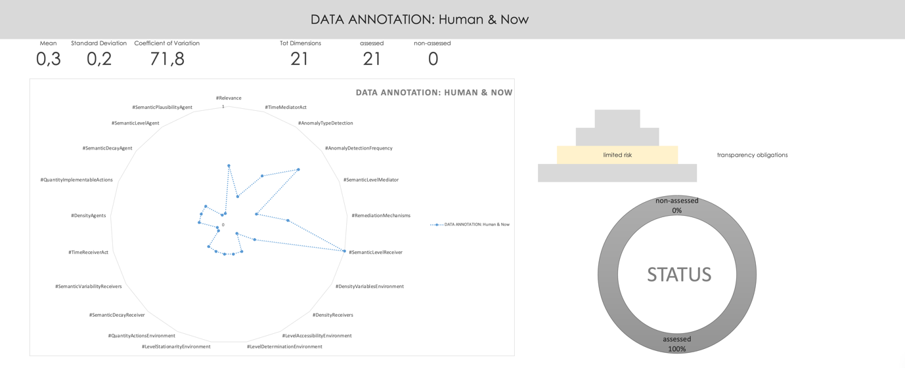
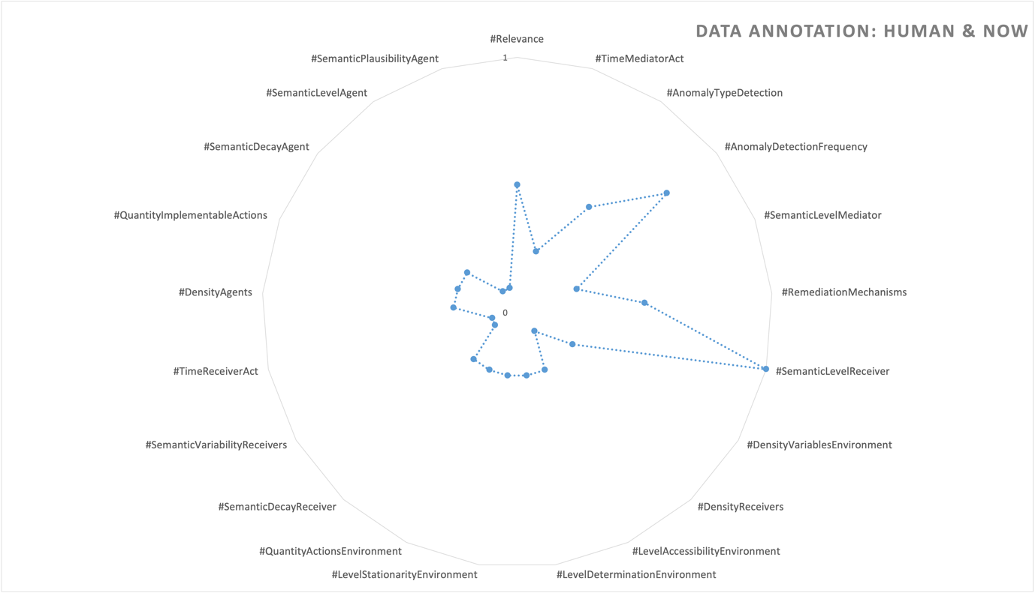

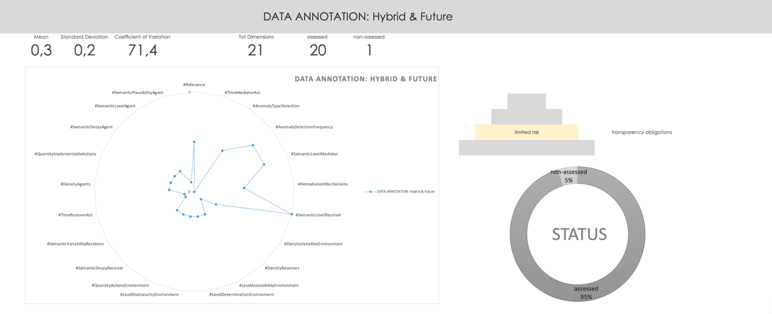
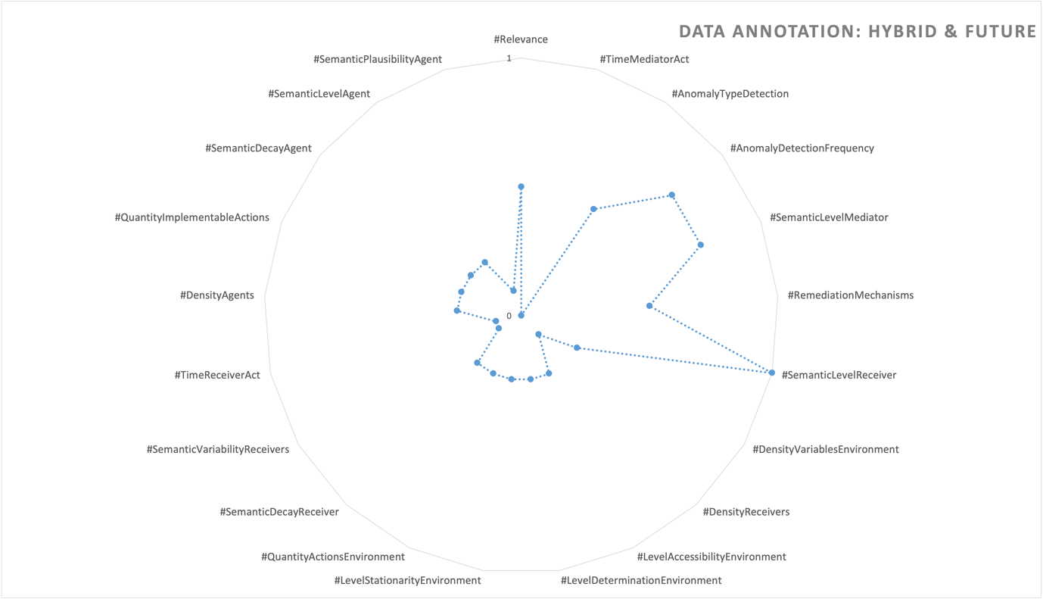

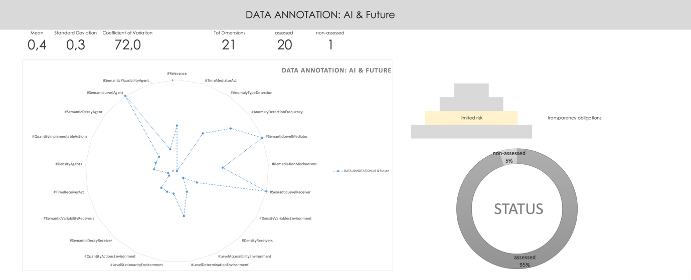
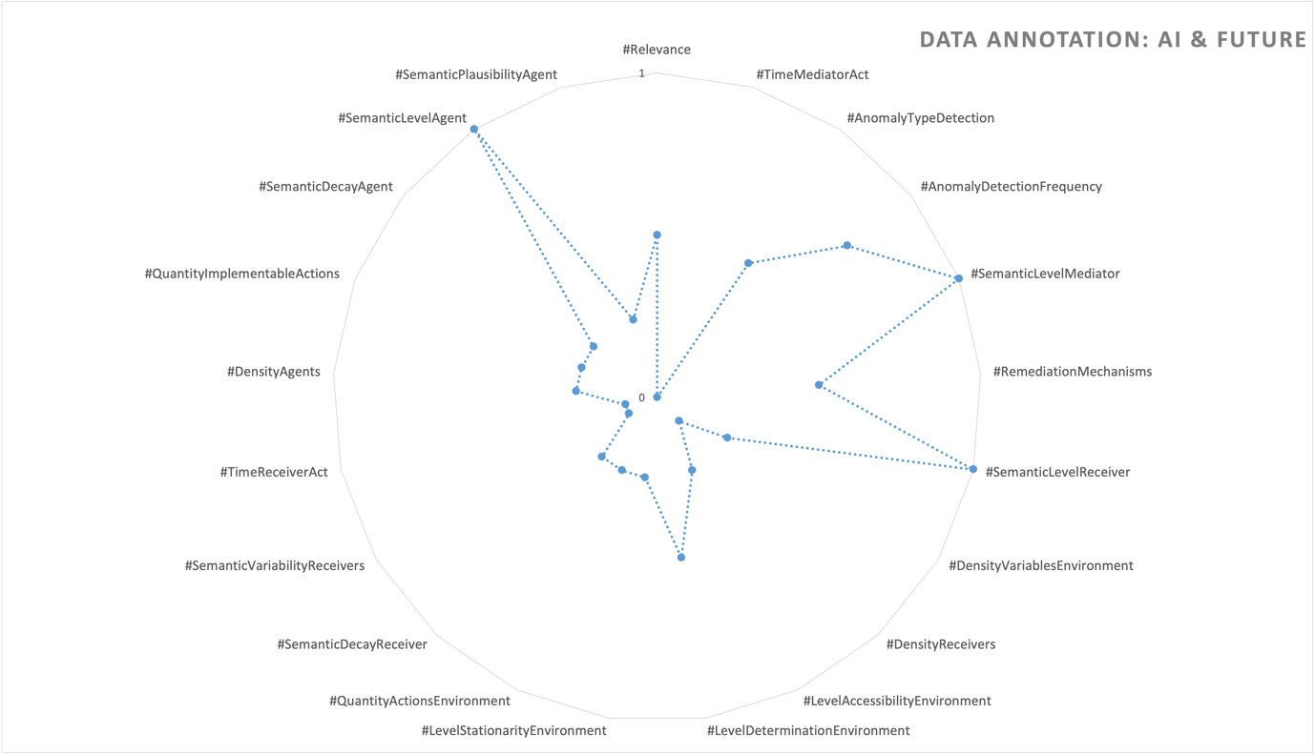

FILTERING
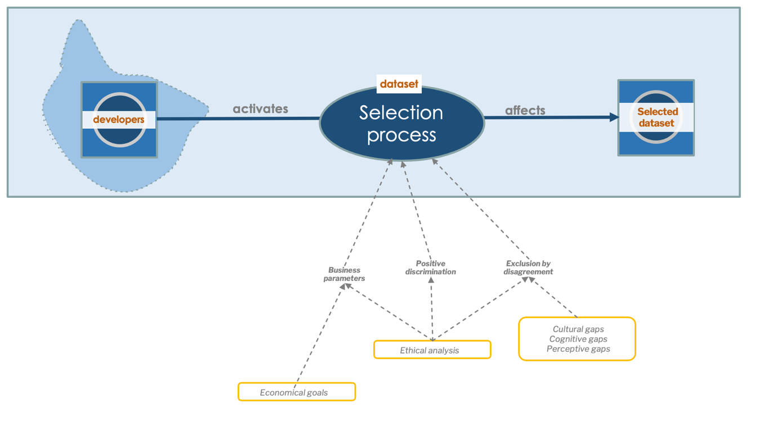
The third phase concerns filtering, i.e. the selection of the data that will be used in the training phase.

The moral situation (DATA FILTERING - DFI) that is generated sees the developers as the agents who activate the selection process using 3 different sources as choice inputs:
- the economic parameters, which should serve the company in determining its strategic choices
- positive discrimination, that is, the set of practices that seek to include particular groups on the basis of their gender, race, sexuality, creed or nationality in sectors where such groups are under-represented
- exclusion by disagreement, in which certain data are excluded because cognitive or perceptual cultural gaps between developers do not allow the agreement to be reached

Mitigation strategies

During the analysis of this moral situation, several elements are of importance and should be considered:

- Ethical evaluation (axiological analysis). Conducting an assessment of ethical values and principles involved in the situation to understand their impact and implications.
- Documentation through the chain of custody of ethical choice. Maintaining a transparent record of decision-making processes and ethical considerations throughout the chain of custody, ensuring accountability and traceability.
- Relevance of positive discrimination. Recognizing that positive discrimination, as an ethical choice made by the company, holds a direct correlation to the situation and should be acknowledged and addressed accordingly.
- Consideration of economic parameters. Acknowledging that economic parameters play a role in decision-making, and their influence should be accounted for and justified in the ethical analysis.
- Addressing exclusion due to disagreement. Recognizing that exclusions based on disagreements may arise and understanding that such choices carry implicit label choices that should be thoroughly documented and justified to maintain transparency and fairness.

Assessment
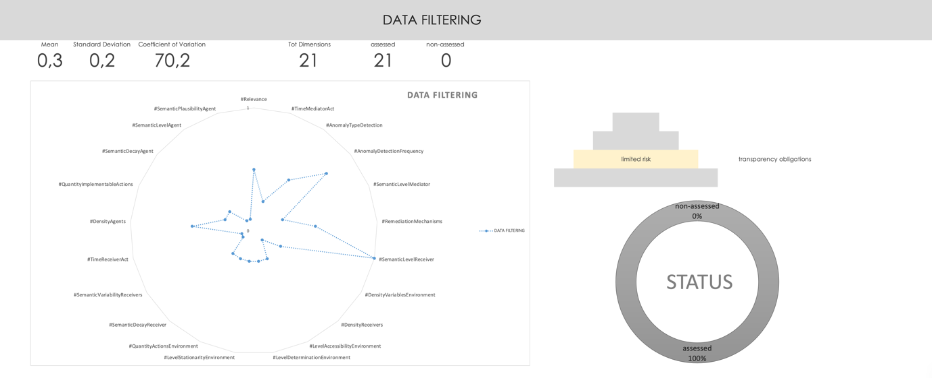
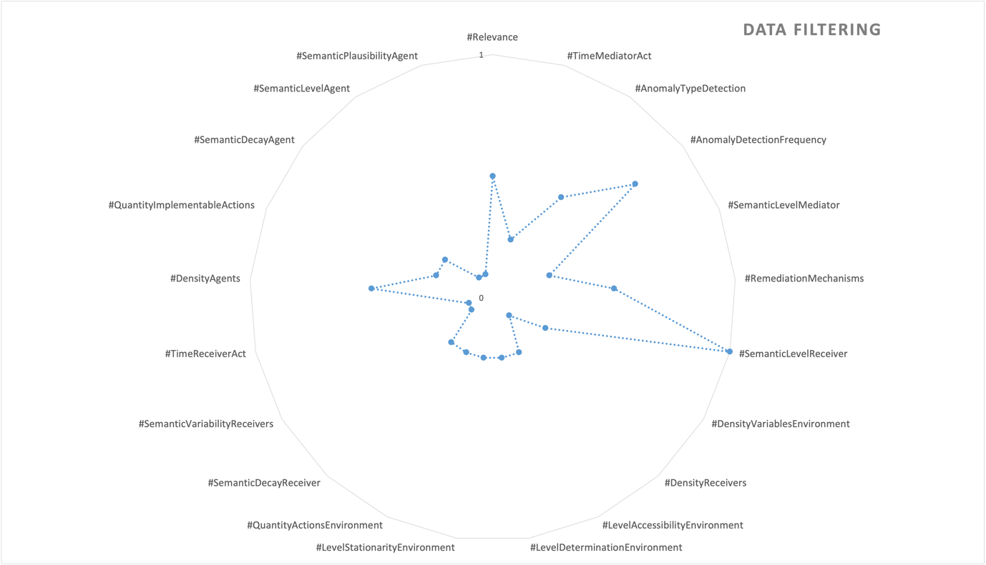

SUGGESTION AI SYSTEM

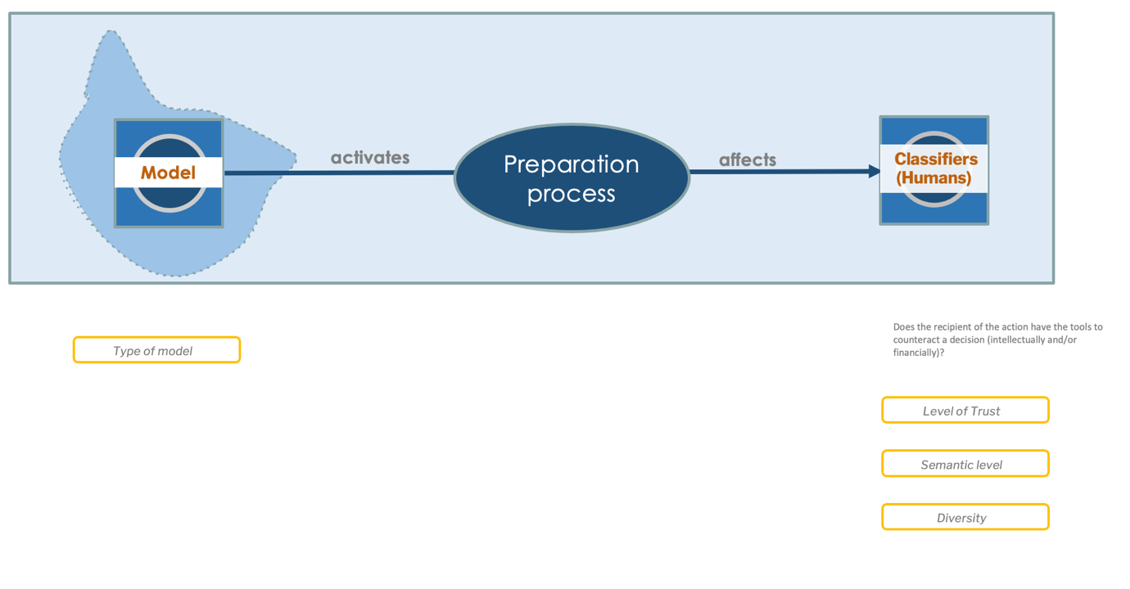
Once trained, the model is ready to help the humans in the classification process.

The model, thanks to its capacity for agency, becomes the agent of the moral situation that impacts the human classifiers (SUGGESTION AI SYSTEM - SAI). In this case, elements highlighted during the analysis of this moral situation:
- the level of confidence of the AI classifier is relevant to guarantee semantic quality during classification.
- the classifier’s semantic level is crucial for discerning suggestions that make sense from those that do not. In practice, the higher the level of expertise of the classifier, the more the semantic quality of the generated classes is guaranteed
- In the case where the classifiers remain only human, the level of diversity of the classifier teams is crucial to ensure the greatest representativeness.

Mitigation strategies
Adapted mitigation strategies for possible ethical risks include:
  - Regular monitoring and calibration of the AI classifier’s confidence level to maintain accuracy and avoid misclassifications.
  - Implementing feedback mechanisms where human experts review and provide inputs to improve the classifier’s performance and refine its semantic understanding.
  - Investing in training and expertise development for the classifier to improve its semantic understanding and decision-making abilities.
  - Incorporating domain-specific knowledge and incorporating expert guidance to enhance the classifier’s semantic capabilities.
  - Forming diverse and inclusive feedback teams that encompass different backgrounds, perspectives, and experiences to avoid biases and improve the overall representativeness of the generated classes.
  - Implementing mechanisms for cross-validation of classifiers within teams to maintain diversity and reduce the risk of individual biases influencing the results.

Assessment
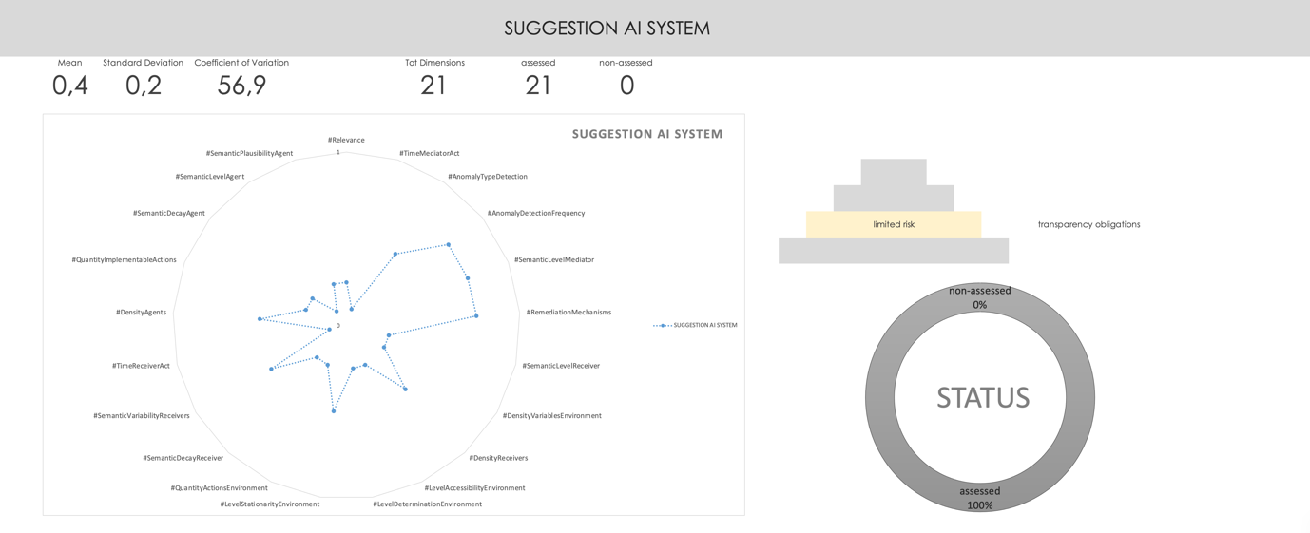
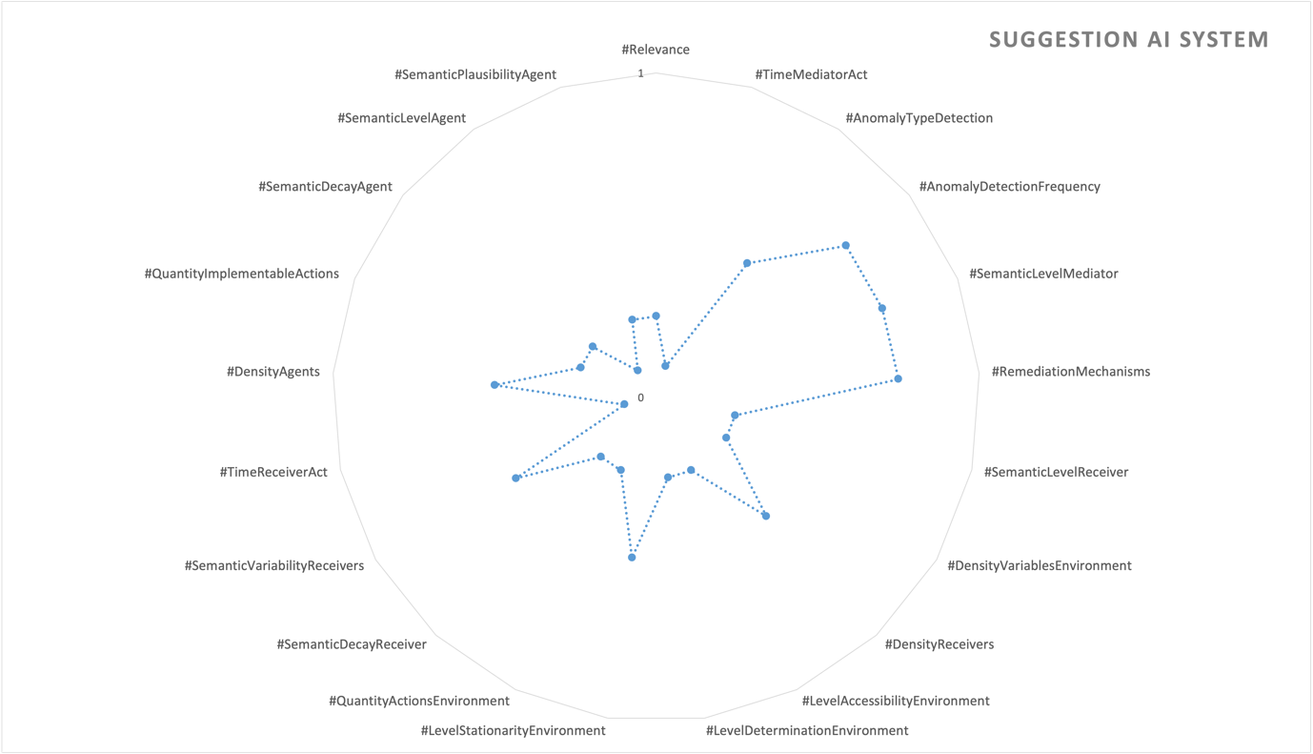

DASHBOARD
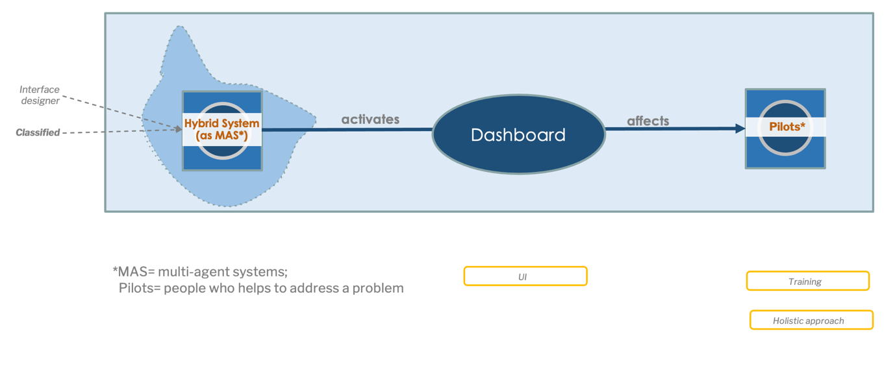
Once classified, problems are distributed to the pilots via a graphical interface (dashboard).

In this case, the moral situation (DASHBOARD – DAS) consists of a multi-agent system that interfaces with the pilots through the dashboard. The multi-agent system is in turn composed of the set of classified data and the behaviour of the interface created by the designers.

Elements highlighted during the analysis of this moral situation
- the communicative capacity of the Dashboard is a relevant element for data interpretation;
- the semantic capacity (i.e. expertise) of the pilots is crucial in the understanding of information mediated by the interface

Mitigation strategies
Adapted mitigation strategies for possible ethical risks include:
- Ensure clear and intuitive design. Design the Dashboard interface in a user-friendly and intuitive manner, with visual cues, clear labels, and appropriate data visualizations to enhance communication and ease interpretation.
- Provide contextual information. Include relevant context and explanations within the Dashboard to aid users in understanding the data presented, reducing the chances of misinterpretation or confusion.
- Conduct user testing and feedback. Gather feedback from users to continuously improve the communicative capacity of the Dashboard, addressing any areas of confusion or ambiguity.
- Training. Provide comprehensive training to pilots, focusing on enhancing their semantic capacity and expertise in interpreting information mediated by the interface. This can involve workshops, seminars, and ongoing skill development programs.
- Collaboration and knowledge sharing. Foster a collaborative environment where pilots can exchange knowledge and experiences, enabling them to enhance their semantic capacity through collective learning.
- Continuous monitoring and evaluation. Regularly assess the pilots’ understanding and interpretation of the information, identifying areas for improvement and providing targeted guidance or support when needed.

Assessment

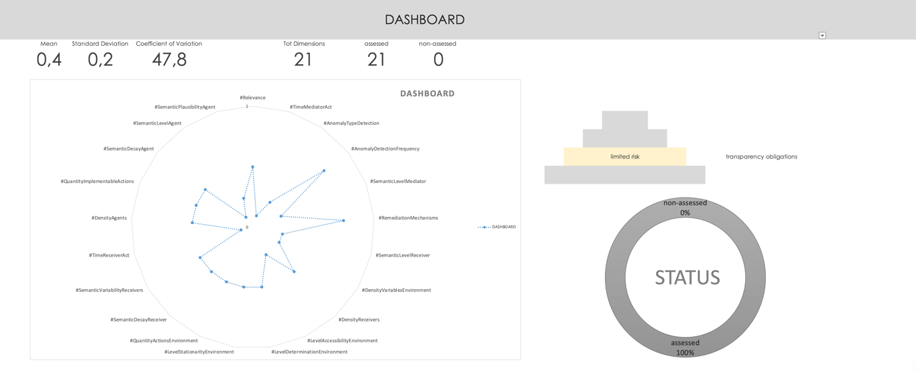
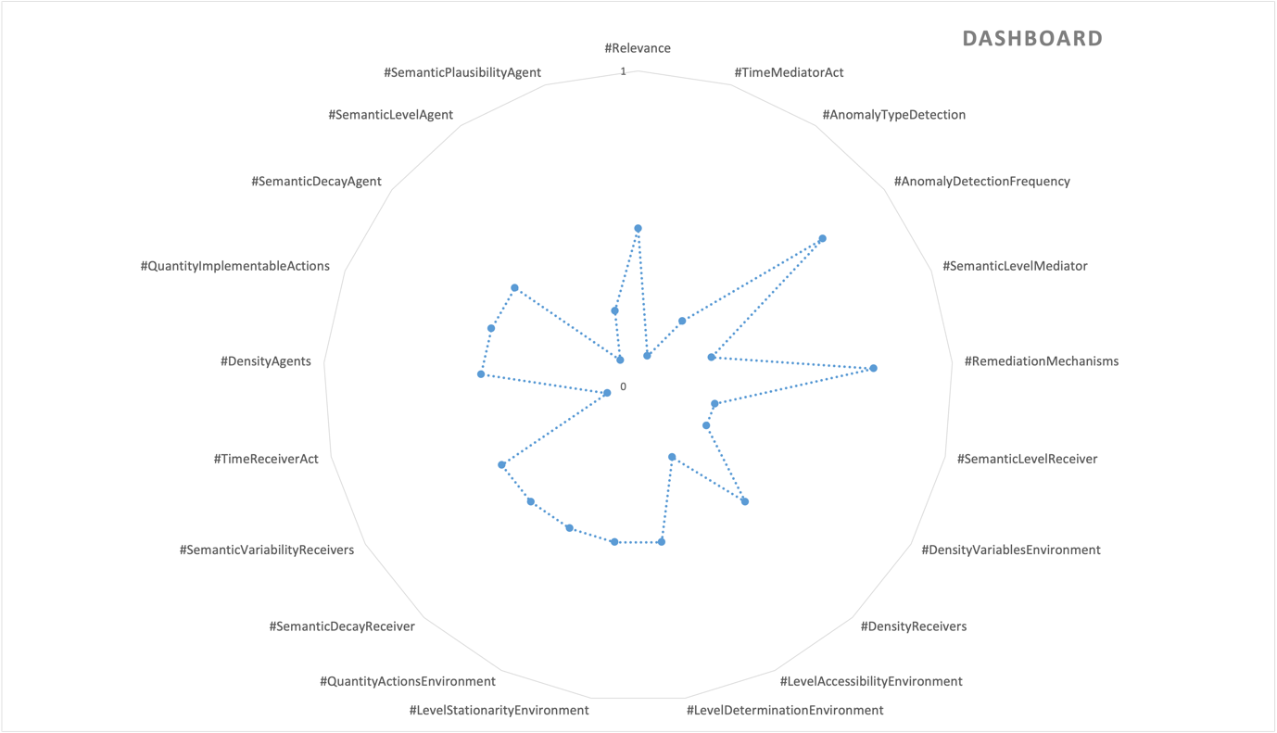

STRATEGIC KNOWLEDGE
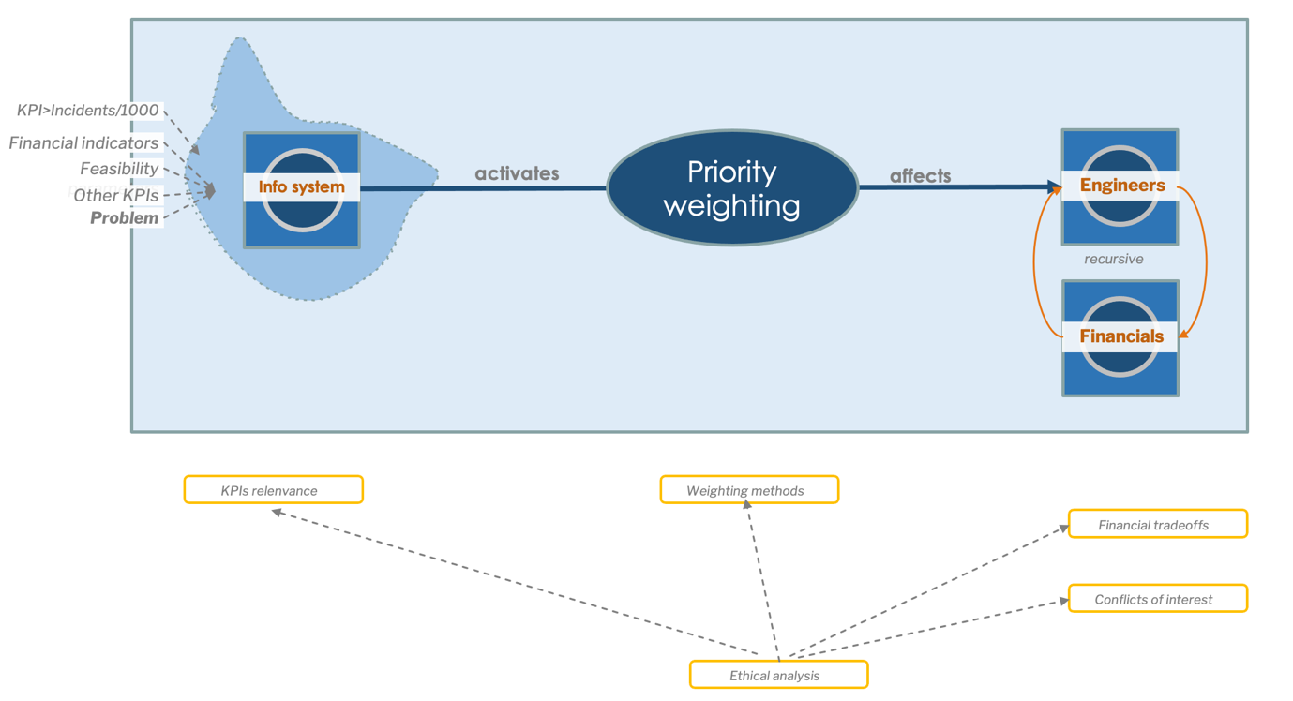
Once classified, the problems are distributed by the pilots to the departments concerned for strategic planning of future production. If necessary, i.e. if the dysfunctions are such that they cause reputational damage to the brand, the pilots will address the complaints directly to the insurance level (quality insurance).

In this case, the moral situation (STRATEGIC KNOWLEDGE - STK) is composed of a multi-agent information system consisting of financial indicators, feasibility elements, classified problems sent by the pilots and other KPIs. The information system is used to weight the various indicators and create priority scales. The receivers of the classified problems are the design and development departments (generically called engineers). This moral situation has the particularity of including a reflexive moral underwriting, in which the decision made by the engineers will directly impact the engineers. In practice, if engineers choose to correct a problem, the financial impact of that correction may influence other choices in design or in solving other problems.

Elements highlighted during the analysis of this moral situation are:
- the semantic capacity (hence expertise) of pilots is crucial in the redirection of classified problems. One must bear in mind that from this point onwards, the redirected information has a major impact on business and production processes. Pilots, in practice, are the pivot element of the transformation of information into knowledge.
- the valorisation of classified problems made by pilots is mediated by an information system that could make the semantic value of the problem to be analysed decay
- in the discussion process, it is not yet clear whether the information system is completely autonomous or whether there is the intervention of human elements in the process that influence the valorisation of priorities. In the second case (the most probable), the choice processes should be evaluated and documented from an ethical point of view.
- the reflexive nature of the substation that is generated between engineers and the finance department could cause conflicts of interest or ethical dilemmas

Mitigation strategies
Adapted mitigation strategies for possible ethical risks include:
- Enhancing pilots’ semantic capacity and expertise. Provide continuous training and professional development opportunities for pilots to enhance their knowledge and skills and foster a culture of knowledge sharing and collaboration among pilots to leverage their collective expertise.
- Establish clear protocols. Helping pilots to follow simple procedures when redirecting classified problems, ensuring consistency and effectiveness.
- Mitigating the decay of semantic. Implementing robust information systems that maintain the semantic value of classified problems throughout the redirection process.
- Periodic audits of the information system to identify and address any issues affecting the valorization of classified problems.
- Ethical assessments. Evalution of the choice processes to identify and address potential biases, conflicts of interest, or unfair prioritization.
- Establish conflict resolution mechanisms. Develop guidelines to address potential conflicts of interest between engineers and the finance department.
- Promote open communication. Enhance the dialogue between the two departments to foster understanding and collaboration while considering ethical implications.
- Moral responsibility. Encourage a culture of ethical decision-making and accountability throughout the organization to mitigate potential ethical dilemmas.

Assessment
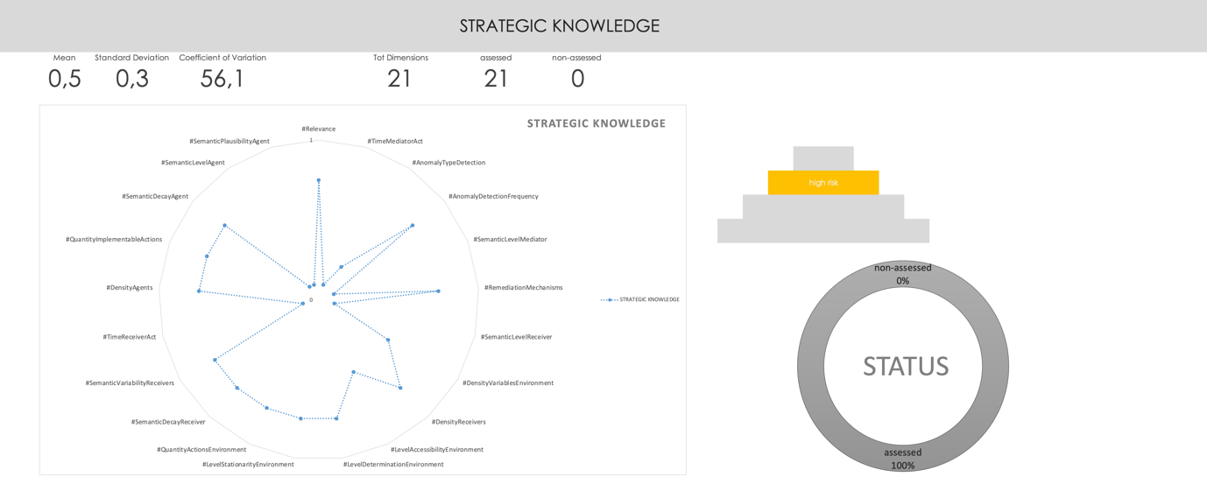
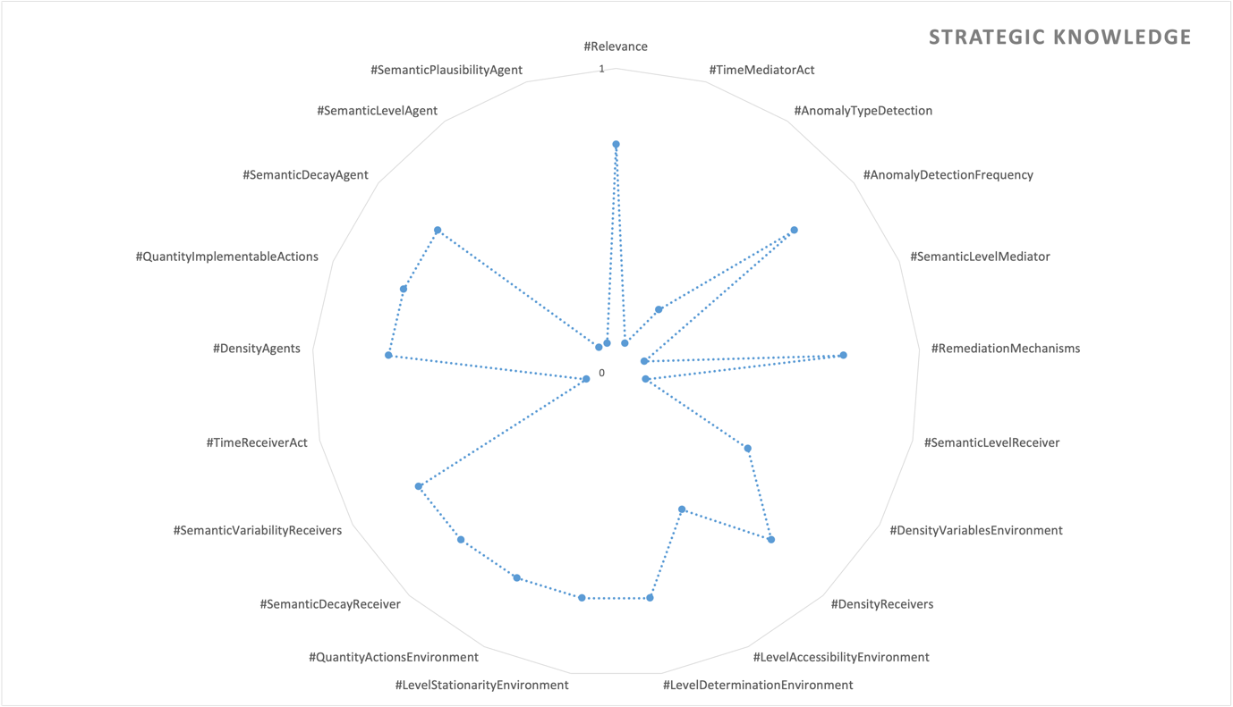

COMMUNICATION LEVEL

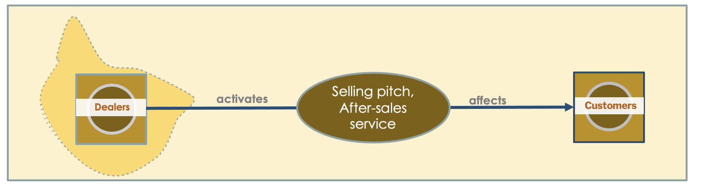
This level has not been addressed. The reason for not addressing this level is attributed to the absence of sufficient information or data necessary for a thorough analysis or understanding.

Further investigation with other stakeholders are necessary to explore and understand this level more comprehensively.

Annexes

Axiological analysis

A series of open-ended questions helps to elicit the identification of the risks posed by this use case. These risks are grouped into several dimensions, referring directly to the informational entities that constitute the moral situation.
An axiological analysis can be conducted for every situation, involving the examination and evaluation of the values at play and their ethical implications.

An axiological analysis is a philosophical and ethical examination that focuses on the study of values, including moral values and principles. It involves assessing and evaluating the inherent worth, significance, and ethical implications of various beliefs, actions, and systems based on their alignment with certain values or value systems. Axiological analysis aims to explore the underlying values and their implications to provide insights into ethical decision-making, moral frameworks, and the overall evaluation of ideas, behaviors, or phenomena in terms of their value-based significance.

In this phase, an axiological analysis assigns a numerical value to a 5-point Likert scale for each dimension. The numerical values are not fixed once and for all but can be ‘tuned’ within the organization to adhere more closely to the particular application under consideration. Likert scale includes descriptive words that are easily understandable by developers. The ethical risk assessment is per-formed, which consists of selecting the right Likert option for each dimension to determine an overall risk level. Finally, a visualization of the risk in the form of a radar chart makes it possible to assess the overall risk level in relation to the risk level of the individual dimensions, facilitating the interplay between a holistic and an analytical perspective.

Data collection
Dimension | DATA COLLECTION: Web
Relevance | financial dignity
TimeMediatorAct | days
AnomalyTypeDetection | Known unknown (narrow range)
AnomalyDetectionFrequency | long period detection
SemanticLevelMediator
RemediationMechanisms | none
SemanticLevelReceiver | inexperienced
DensityVariablesEnvironment | more unknown variables
DensityReceivers | no human involved
LevelAccessibilityEnvironment | more unknown variables
LevelDeterminationEnvironment | With some non-deterministic consequences
LevelStationarityEnvironment | Slight impact on the environment
QuantityActionsEnvironment | a limited number of actions
SemanticDecayReceiver | Slight semantic change
SemanticVariabilityReceivers | Narrow and uniform semantics
TimeReceiverAct | months
DensityAgents | Single agent
QuantityImplementableActions | Few actions
SemanticDecayAgent | Slight semantic change
SemanticLevelAgent | AI
SemanticPlausibilityAgent | No imitation (AI is clearly recognisable)

Dimension | DATA COLLECTION: Survey  (benchmarketed)
Relevance | financial dignity
TimeMediatorAct | days
AnomalyTypeDetection | Known unknown (narrow range)
AnomalyDetectionFrequency | long period detection
SemanticLevelMediator | expert human in the process
RemediationMechanisms | none
SemanticLevelReceiver | inexperienced
DensityVariablesEnvironment | all variables are known
DensityReceivers | no human involved
LevelAccessibilityEnvironment | more known variables
LevelDeterminationEnvironment | Hybrid
LevelStationarityEnvironment | Slight impact on the environment
QuantityActionsEnvironment | a limited number of actions
SemanticDecayReceiver | Slight semantic change
SemanticVariabilityReceivers | Narrow and uniform semantics
TimeReceiverAct | months
DensityAgents | Single agent
QuantityImplementableActions | Few actions
SemanticDecayAgent | Slight semantic change
SemanticLevelAgent | aware human in the process
SemanticPlausibilityAgent | No imitation (AI is clearly recognisable)

Dimension | DATA COLLECTION: Internal Survey SAV
Relevance | financial dignity
TimeMediatorAct | days
AnomalyTypeDetection | Known unknown (narrow range)
AnomalyDetectionFrequency | long period detection
SemanticLevelMediator | aware human in the process
RemediationMechanisms | in regular basis
SemanticLevelReceiver | inexperienced
DensityVariablesEnvironment | more known variables
DensityReceivers | no human involved
LevelAccessibilityEnvironment | fifty/fifty
LevelDeterminationEnvironment | Hybrid
LevelStationarityEnvironment | Slight impact on the environment
QuantityActionsEnvironment | a limited number of actions
SemanticDecayReceiver | Slight semantic change
SemanticVariabilityReceivers | Narrow and uniform semantics
TimeReceiverAct | months
DensityAgents | Non monolotic multiagent (Swarm Agent)
QuantityImplementableActions | Few actions
SemanticDecayAgent | Slight semantic change
SemanticLevelAgent | expert human in the process
SemanticPlausibilityAgent | No imitation (AI is clearly recognisable)

Dimension | DATA COLLECTION: Internal Survey Seller
Relevance | financial dignity
TimeMediatorAct | days
AnomalyTypeDetection | Known unknown (narrow range)
AnomalyDetectionFrequency | long period detection
SemanticLevelMediator | aware human in the process
RemediationMechanisms | in regular basis
SemanticLevelReceiver | inexperienced
DensityVariablesEnvironment | more known variables
DensityReceivers | no human involved
LevelAccessibilityEnvironment | fifty/fifty
LevelDeterminationEnvironment | Hybrid
LevelStationarityEnvironment | Slight impact on the environment
QuantityActionsEnvironment | a limited number of actions
SemanticDecayReceiver | Slight semantic change
SemanticVariabilityReceivers | Narrow and uniform semantics
TimeReceiverAct | months
DensityAgents | Non monolotic multiagent (Swarm Agent)
QuantityImplementableActions | Few actions
SemanticDecayAgent | Slight semantic change
SemanticLevelAgent | expert human in the process
SemanticPlausibilityAgent | No imitation (AI is clearly recognisable)

Data annotation
Dimension | DATA ANNOTATION: Human & Now
Relevance | financial dignity
TimeMediatorAct | days
AnomalyTypeDetection | Known unknown (narrow range)
AnomalyDetectionFrequency | long period detection
SemanticLevelMediator | aware human in the process
RemediationMechanisms | in regular basis
SemanticLevelReceiver | inexperienced
DensityVariablesEnvironment | more known variables
DensityReceivers | no human involved
LevelAccessibilityEnvironment | more known variables
LevelDeterminationEnvironment | With some non-deterministic consequences
LevelStationarityEnvironment | Slight impact on the environment
QuantityActionsEnvironment | a limited number of actions
SemanticDecayReceiver | Slight semantic change
SemanticVariabilityReceivers | Narrow and uniform semantics
TimeReceiverAct | months
DensityAgents | Single agent
QuantityImplementableActions | Few actions
SemanticDecayAgent | Slight semantic change
SemanticLevelAgent | expert human in the process
SemanticPlausibilityAgent | No imitation (AI is clearly recognisable)

Dimension | DATA ANNOTATION: Hybrid & Future
Relevance | financial dignity
TimeMediatorAct
AnomalyTypeDetection | Known unknown (narrow range)
AnomalyDetectionFrequency | long period detection
SemanticLevelMediator | expert system
RemediationMechanisms | in regular basis
SemanticLevelReceiver | inexperienced
DensityVariablesEnvironment | more known variables
DensityReceivers | no human involved
LevelAccessibilityEnvironment | more known variables
LevelDeterminationEnvironment | With some non-deterministic consequences
LevelStationarityEnvironment | Slight impact on the environment
QuantityActionsEnvironment | a limited number of actions
SemanticDecayReceiver | Slight semantic change
SemanticVariabilityReceivers | Narrow and uniform semantics
TimeReceiverAct | months
DensityAgents | Single agent
QuantityImplementableActions | Few actions
SemanticDecayAgent | Slight semantic change
SemanticLevelAgent | aware human in the process
SemanticPlausibilityAgent | No imitation (AI is clearly recognisable)

Dimension | DATA ANNOTATION: AI & Future
Relevance | financial dignity
TimeMediatorAct
AnomalyTypeDetection | Known unknown (narrow range)
AnomalyDetectionFrequency | long period detection
SemanticLevelMediator | AI
RemediationMechanisms | in regular basis
SemanticLevelReceiver | inexperienced
DensityVariablesEnvironment | more known variables
DensityReceivers | no human involved
LevelAccessibilityEnvironment | more known variables
LevelDeterminationEnvironment | Hybrid
LevelStationarityEnvironment | Slight impact on the environment
QuantityActionsEnvironment | a limited number of actions
SemanticDecayReceiver | Slight semantic change
SemanticVariabilityReceivers | Narrow and uniform semantics
TimeReceiverAct | months
DensityAgents | Single agent
QuantityImplementableActions | Few actions
SemanticDecayAgent | Slight semantic change
SemanticLevelAgent | AI
SemanticPlausibilityAgent | Lingustic imitation

Filtering
Dimension | DATA FILTERING
Relevance | financial dignity
TimeMediatorAct | days
AnomalyTypeDetection | Known unknown (narrow range)
AnomalyDetectionFrequency | long period detection
SemanticLevelMediator | aware human in the process
RemediationMechanisms | in regular basis
SemanticLevelReceiver | inexperienced
DensityVariablesEnvironment | more known variables
DensityReceivers | no human involved
LevelAccessibilityEnvironment | more known variables
LevelDeterminationEnvironment | With some non-deterministic consequences
LevelStationarityEnvironment | Slight impact on the environment
QuantityActionsEnvironment | a limited number of actions
SemanticDecayReceiver | Slight semantic change
SemanticVariabilityReceivers | Narrow and uniform semantics
TimeReceiverAct | months
DensityAgents | Monolitic multigent
QuantityImplementableActions | Few actions
SemanticDecayAgent | Slight semantic change
SemanticLevelAgent | expert human in the process
SemanticPlausibilityAgent | No imitation (AI is clearly recognisable)

Suggestion AI
Dimension | SUGGESTION AI SYSTEM
Relevance | nuisances
TimeMediatorAct | months
AnomalyTypeDetection | Known unknown (narrow range)
AnomalyDetectionFrequency | long period detection
SemanticLevelMediator | expert system
RemediationMechanisms | after a legal claim
SemanticLevelReceiver | proficient
DensityVariablesEnvironment | more known variables
DensityReceivers | small subgroup (i.e. family)
LevelAccessibilityEnvironment | more known variables
LevelDeterminationEnvironment | With some non-deterministic consequences
LevelStationarityEnvironment | Hybrid
QuantityActionsEnvironment | a limited number of actions
SemanticDecayReceiver | Slight semantic change
SemanticVariabilityReceivers | Shared semantics
TimeReceiverAct | months
DensityAgents | Monolitic multigent
QuantityImplementableActions | Few actions
SemanticDecayAgent | Slight semantic change
SemanticLevelAgent | expert human in the process
SemanticPlausibilityAgent | Lingustic imitation

Dashboard
Dimension | DASHBOARD
Relevance | financial dignity
TimeMediatorAct | months
AnomalyTypeDetection | Known unknown (wide range)
AnomalyDetectionFrequency | long period detection
SemanticLevelMediator | aware human in the process
RemediationMechanisms | after a legal claim
SemanticLevelReceiver | proficient
DensityVariablesEnvironment | more known variables
DensityReceivers | small subgroup (i.e. family)
LevelAccessibilityEnvironment | more known variables
LevelDeterminationEnvironment | Hybrid
LevelStationarityEnvironment | Hybrid
QuantityActionsEnvironment | a moderate number of actions
SemanticDecayReceiver | Normalised semantic change
SemanticVariabilityReceivers | Shared semantics
TimeReceiverAct | months
DensityAgents | Monolitic multigent
QuantityImplementableActions | Average number of actions for system
SemanticDecayAgent | Normalised semantic change
SemanticLevelAgent | expert human in the process
SemanticPlausibilityAgent | Lingustic imitation

Strategic knowledge
Dimension | STRATEGIC KNOWLEDGE
Relevance | psychological
TimeMediatorAct | months
AnomalyTypeDetection | Known unknown (wide range)
AnomalyDetectionFrequency | long period detection
SemanticLevelMediator | expert human in the process
RemediationMechanisms | after a legal claim
SemanticLevelReceiver | experts
DensityVariablesEnvironment | fifty/fifty
DensityReceivers | lager subgroup (i.e. school)
LevelAccessibilityEnvironment | fifty/fifty
LevelDeterminationEnvironment | With many non-deterministic consequences
LevelStationarityEnvironment | High impact on the environment
QuantityActionsEnvironment | a large number of adversarial actions
SemanticDecayReceiver | Important semantic chage
SemanticVariabilityReceivers | Social semantics
TimeReceiverAct | months
DensityAgents | Non monolotic multiagent (Swarm Agent)
QuantityImplementableActions | Large number of actions
SemanticDecayAgent | Important semantic chage
SemanticLevelAgent | expert human in the process
SemanticPlausibilityAgent | No imitation (AI is clearly recognisable)

