Valeo

Valeo is a leading automotive supplier that develops a range of sensors and AI technologies for self-driving cars. The company’s sensor suite includes cameras, lidar, radar, and ultrasonic sensors that provide a 360-degree view of the vehicle’s surroundings. These sensors are integrated with Valeo’s AI algorithms (Convolutional Neural Networks embedded on an Electronic Control Unit), which use deep learning and computer vision techniques to analyse the data and make decisions in real-time. The company’s AI technologies enable self-driving cars to detect and track objects, recognise traffic signs and signals, parking assistance, and anticipate the movements of other vehicles and pedestrians.

The study conducted for Valeo is based on the analysis of moral situations to understand what kind of moral issues this system can raise.

Initially we will introduce the method based on the moral situation, the spaces (phases) where the moral situation raise and finally we will analyse each phase as elements of a moral situation.

The use case and mapping of spaces for Valeo

Introduction

The study done for Valeo is based on the analysis of moral situations arising in the production pipeline (from data collection to the driving choice of single vehicle). In the production pipeline, the various steps were developed following the classical Data Information Knowledge structure.

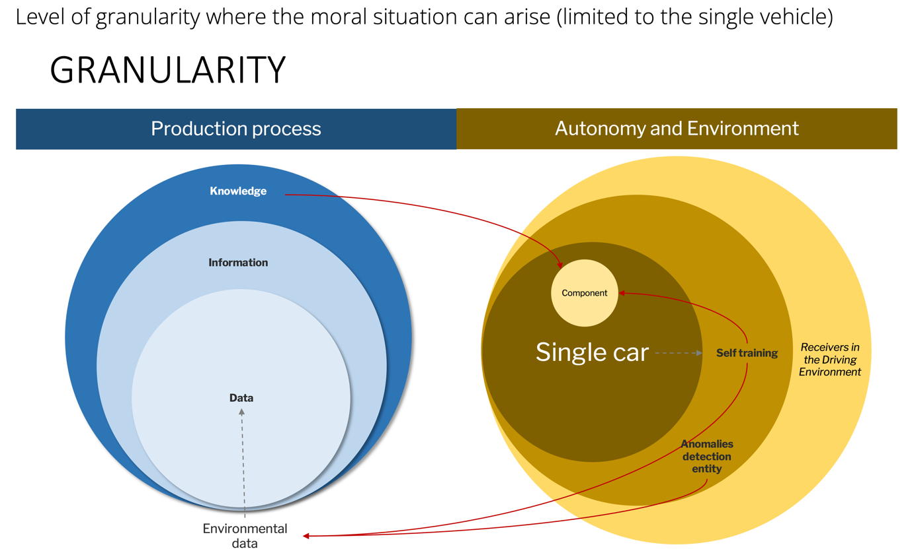

Figure 5 - Level of granularity related to this use case

Limitations
The level of granularity needed emerged from the discussion with Valeo and was refined during the divisional meetings. This is an experimental top-down use case, so not all stakeholders in the process were present in defining the scope of action and the level of granularity needed. The study therefore entails an epistemological limitation that should be bridged in the case of real application.

The levels of cartography

This case study considers only the stages of the production process, as these are currently the only ones about which factual semantic information can be obtained at this stade.

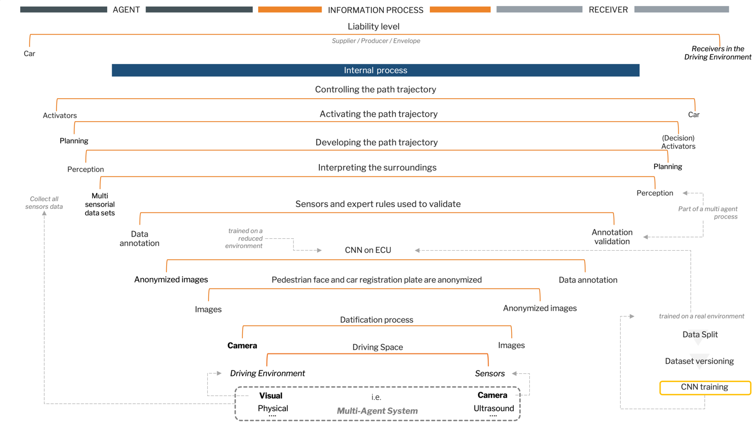
Figure 6 - Detected moral situations

During the process, Valeo was asked to technically describe the various stages of the process and for each stage the moral situations on which to ask questions were identified together. This resulted in the following list of moral situations, as shown in Figure 6:
- Driving space
- Datafication process
- Anonymization
- Annotation/Validation
- Data Versioning
- Data Split
- CNN - Convolutional Neural Networks
- Interpreting the surroundings
- Decision process & Path Trajectory
- Liability level

In the following sections, the moral situations are described one by one.

Driving Space
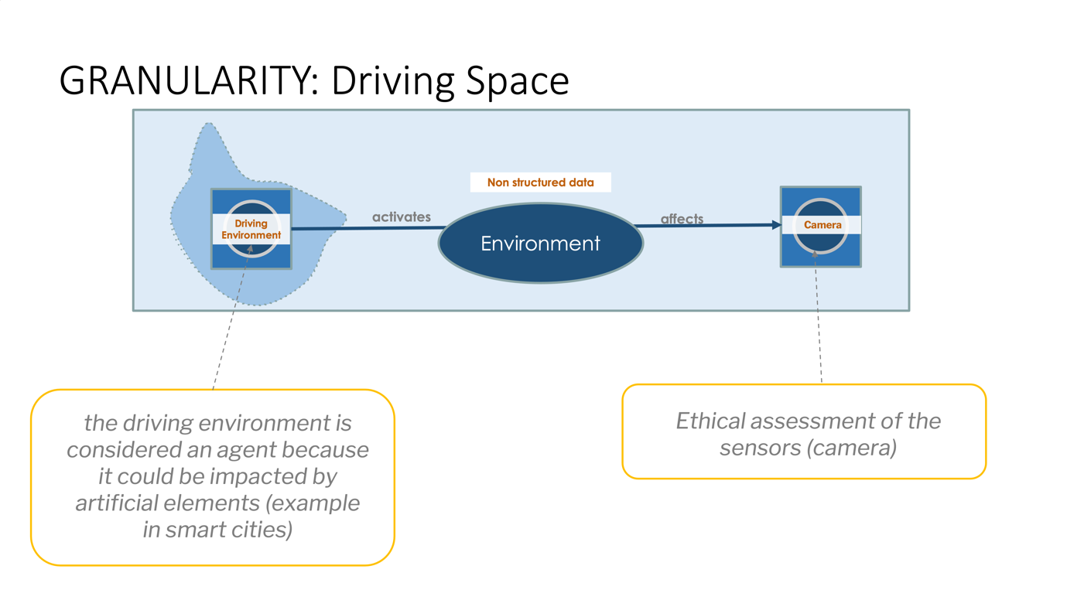

A driving space can be considered as a multiagent system because it involves interactions between various entities or agents that influence the behaviour and decisions of an autonomous car’s driving system. These agents can include other vehicles, pedestrians, cyclists, traffic signals, and infrastructure elements.

Characteristics that explain why a driving space is considered a multiagent system (MAS).
- Autonomy: agents are (at least partially) independent
- Local views: no agent has a full global view, or the system is too complex for an agent to exploit such knowledge
- Decentralization: no agent is designated as controlling (or the system is effectively reduced to a monolithic system)

In this space, some factors are to be taken into account:
- Interactions and dependencies. Multiple agents interact and depend on each other’s actions. The behavior of one agent affects the behavior of others, creating a complex network of interactions.
- Dynamic environment. Agents continuously move and change their states:
- Coordination and cooperation. Agents often need to coordinate and cooperate to ensure safe and efficient traffic flow:
- Uncertainty and partial observability. Agents operates under conditions of uncertainty and partial observability. It cannot have complete knowledge of the intentions or states of other agents in the driving space. The driving system needs to make predictions and infer the behaviors of other agents based on their observed actions, sensor data, and models of human behavior.
- Safety considerations: The actions and decisions of each agent in the driving space pose potential risks and safety challenges for other agents.

Considerations

Given that this particular use case involves analyzing an “autonomous parking system,” the ethical considerations involved are significantly reduced compared to systems that handle more complex variables at higher speeds. However, conducting an ethical assessment of how the cameras react to the driving space would still be appropriate.

Mitigation strategies
Mitigation strategies include:

- Continuous monitoring and auditing. Implementing systems for ongoing monitoring and auditing of autonomous car behaviour to identify and address any ethical violations or deviations from established guidelines. This ensures accountability and enables prompt corrective actions.
- Transparent and explainable AI. Employing transparent and explainable AI techniques to enhance the understandability of the decision-making processes of autonomous car systems. This allows stakeholders to have insight into how decisions are made and promotes trust in the system.
- Public engagement and feedback. Encouraging public engagement and seeking feedback from stakeholders, including the community, regulators, and experts, to gather diverse perspectives and ensure that ethical considerations are taken into account during the development and deployment of autonomous car systems.

Engineers have expressed concerns about the lack of sharing difficult cases, but they believe that creating a shared benchmark would be advantageous for the automotive market.

Assessment
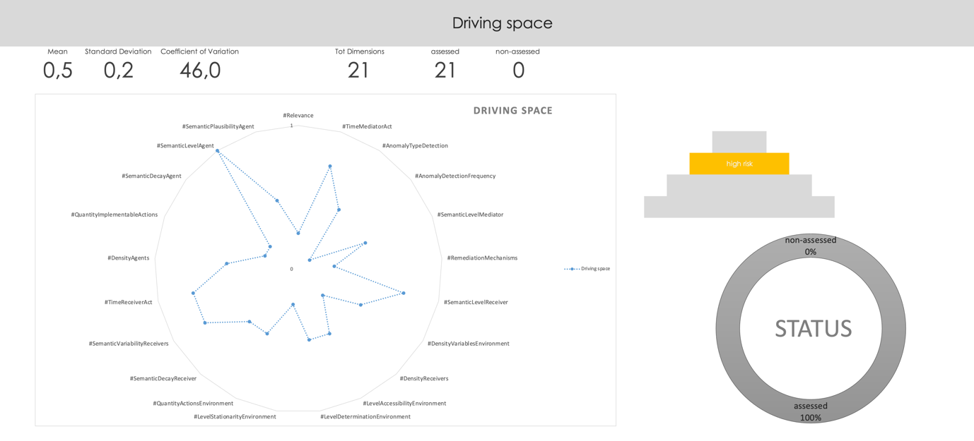
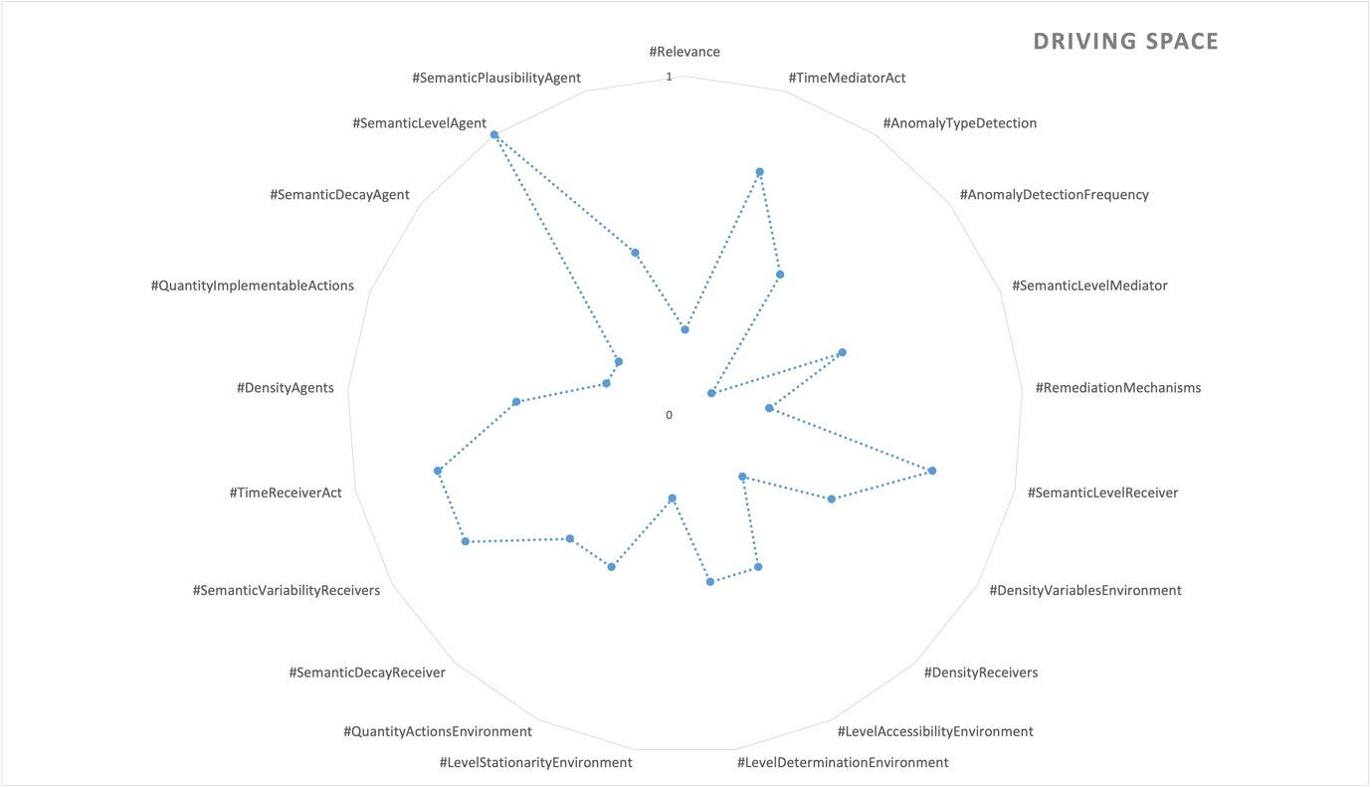

Datafication process
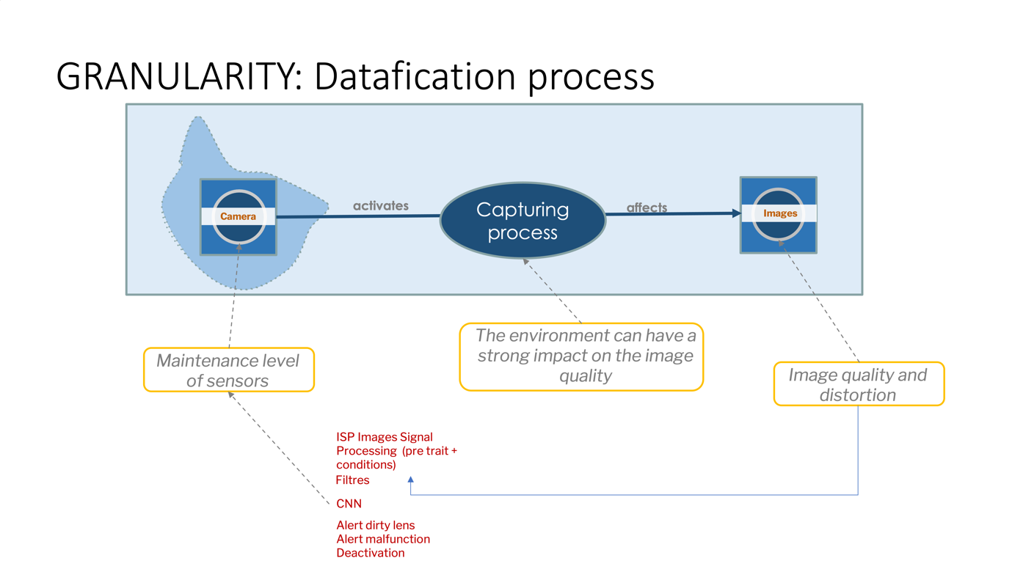
The datafication process involves transforming the world into computable data to enable the functioning of these systems, namely converting various aspects of the real world, such as the environment, objects, events, and human behavior, into digital data that can be processed and understood by digital interfaces. This process involves collecting data from sensors, cameras, LIDAR, radar, and other sources, and encoding it into a format that can be analyzed and interpreted by AI algorithms, as in Figure 7.
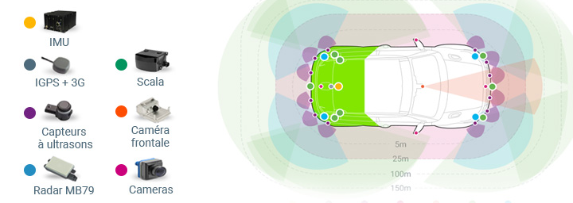
Figure 7 - Examples of Valeo’s sensors

By transforming the world into computable data, these systems can analyse and interpret their surroundings, make informed decisions, and navigate safely and efficiently. However, it’s important to consider the ethical implications of datafication, including privacy concerns, data security, and potential biases introduced during the data collection and processing stages.
The datasets used are shown in Table 2. It is evident that certain datasets have geographic limitations that affect the semantic understanding of the environment. Moreover, the presence of identifiable objects restricts the moral situation to known elements such as pedestrians, vehicles, traffic lights, and signs, thereby significantly increasing the risk associated with unknown factors or scenarios.

Table 2 - Used datasets
Image types | Size | Providedby Valeo | Private/ public | Annotations | Diversity | Image types
Woodscape | Fisheye images | 8K | Yes | Public | object, semantic segmentation, motion, end2end driving | Low
Woodscape Error | Fisheye images | 2.5K (700 with error in the lanes annotations) | Yes | Private | Semantic segmentation, and label on lane annotation correct/false | NA
Valeo Deep Perception | Fisheye images | 120K labelled+ 100K unlabelled data | Yes | Private | object, semantic segmentation | Geographical (cities in France, Germany, USA, Japan)
BDD100K  Is a publicly available dataset | High resolution videos | 100K sequences, up to 70K images annotated | No | Public | Multi-task (object, lane semantic segmentation, instance segmentation etc) Details | Geographical (NY, SF area), weather, scene types, time of day

Mitigation strategies
By addressing sensor maintenance and accounting for environmental impacts, steps can be taken to mitigate noise, enhance image quality, and minimise data distortion. This ultimately contributes to the effectiveness and performance of autonomous car systems in perceiving and navigating their surroundings.
- Robust sensor maintenance. Implementing regular maintenance protocols to ensure sensors are functioning optimally, detecting and addressing any issues promptly, and conducting quality checks to reduce the risk of data inaccuracies or biases.
- Environmental adaptation. Developing AI algorithms and models that can adapt to varying environmental conditions by accounting for factors such as luminosity, weather conditions, and other variables to minimise the impact on image quality and data accuracy.
- Bias detection and mitigation. Actively monitoring for biases in the data, including biases introduced by environmental factors, and employing techniques to detect and mitigate them. This can involve analyzing data distributions, conducting fairness audits, and applying bias-correction methods to ensure equitable treatment and avoid discriminatory outcomes.
- Data augmentation and diversification. Augmenting the dataset with a diverse range of environmental conditions and scenarios to ensure robustness and reduce the risk of over-reliance on specific environmental contexts. This helps prevent biases and ensures the AI system’s ability to generalise across various conditions.

Currently, there are no immediate intentions to incorporate evolutionary models for new environments; however, future developments may explore the potential for enhanced adaptability, which would introduce novel ethical considerations regarding the interaction between cars and their surroundings.

Assessment
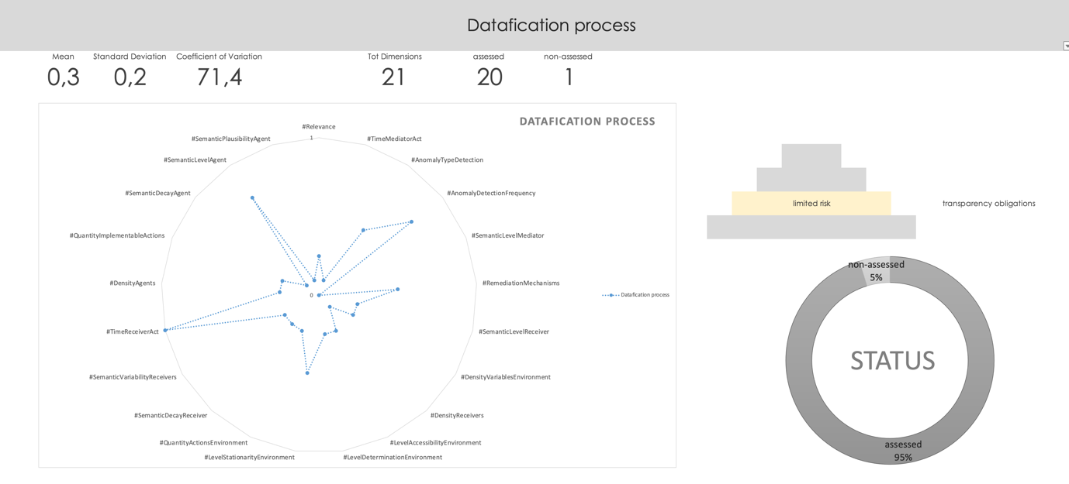
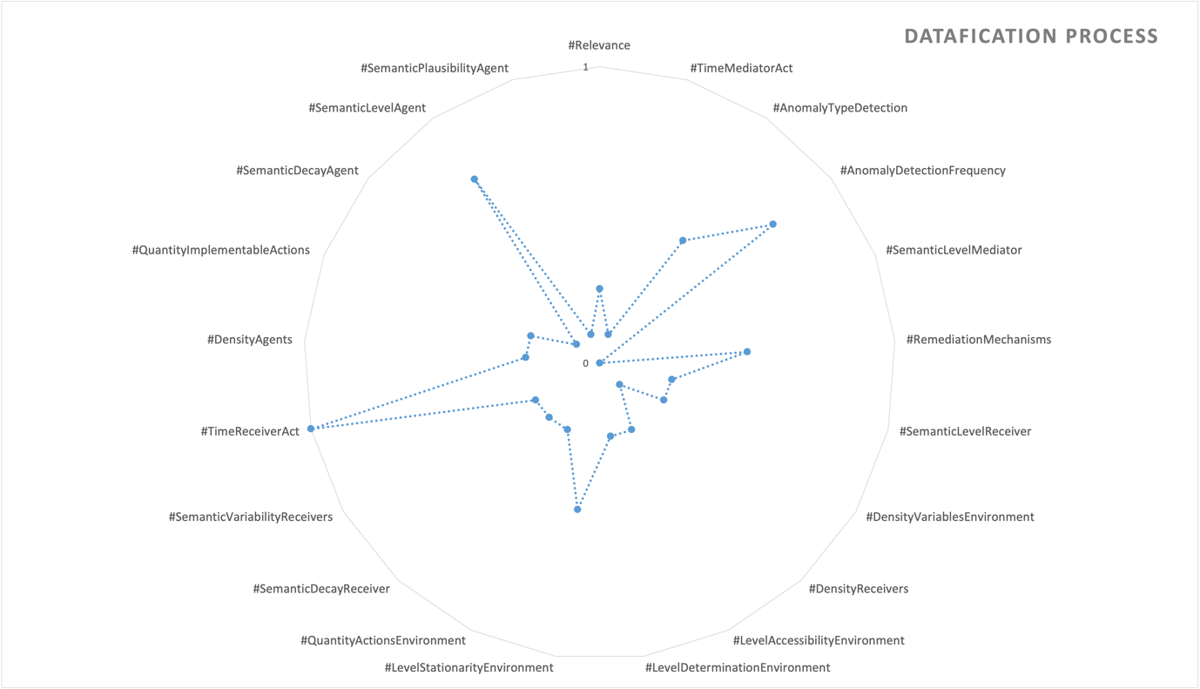

Anonymization
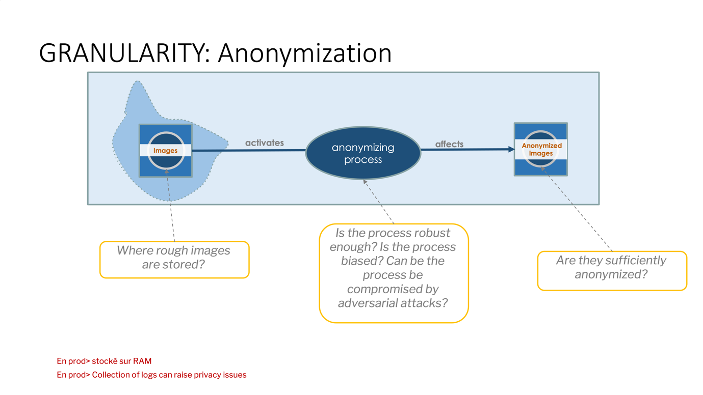

The anonymization process of images used to train Convolutional Neural Networks (CNNs) involves several steps to protect individuals’ privacy, namely removing or obfuscating any personal identifiable information from the images in the dataset. This can include faces, license plates, or any other identifiable features. Techniques such as blurring, pixelation, or masking may be used to achieve this.

Ethical risks associated with the anonymization process include:
- Storage of rough (non-anonymized) images. If the rough images containing identifiable information are stored insecurely or accessible to unauthorized individuals, there is a risk of privacy breaches and potential misuse of personal data.
- Robustness of the anonymization process. In removing personal identifiable information without compromising the usefulness of the dataset for training CNNs. Inaccurate or insufficient anonymization techniques can result in residual information that can still lead to re-identification, thereby violating individuals’ privacy.
- Biases created by the anonymization process. In fact, the process may inadvertently introduce biases into the dataset. As the Irish Effect demonstrated (see below)
- Adversarial attacks: Adversarial attacks involve deliberately manipulating the anonymized images to exploit vulnerabilities in the CNN model. By injecting carefully crafted perturbations, an attacker may attempt to cause misclassification or degrade the performance of the model, compromising its reliability and potentially causing harm.

The Irish Effect.
The scenario discussed involved training models using datasets collected in Ireland, where the prevailing weather conditions often included cloudy or grey skies. As a consequence, during sunny days, the models misinterpreted the sky as the sea.

Mitigation strategies
To address these ethical risks, it is essential to employ secure storage practices, ensure the effectiveness and accuracy of anonymization techniques, consider the potential biases introduced during anonymization, and implement robust security measures to protect against adversarial attacks.

- Secure storage. Implementing secure storage practices to safeguard the dataset and prevent unauthorized access.
- Re-identification attack. Ensuring the effectiveness and accuracy of anonymization techniques to protect individuals’ privacy while maintaining the usefulness of the data.
- Bias detection. Being mindful of potential biases introduced during the anonymization process and taking steps to mitigate and address them.
- Adversarial attacks. Implementing robust security measures to protect against adversarial attacks, ensuring the integrity of the dataset and the reliability of the AI system.
- Audit. Conducting regular third part independent audits, monitoring, and evaluation of the anonymization process to identify any vulnerabilities or privacy breaches and take corrective actions as necessary.
By implementing these mitigation strategies, organizations can strive to maintain the privacy, integrity, and ethical standards of the dataset used for training AI models.

Assessment
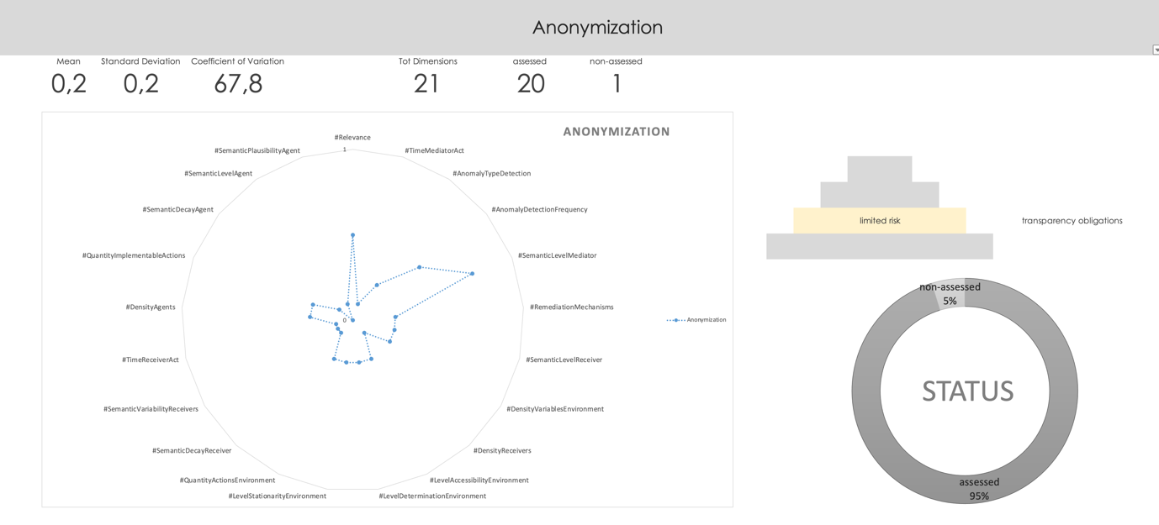
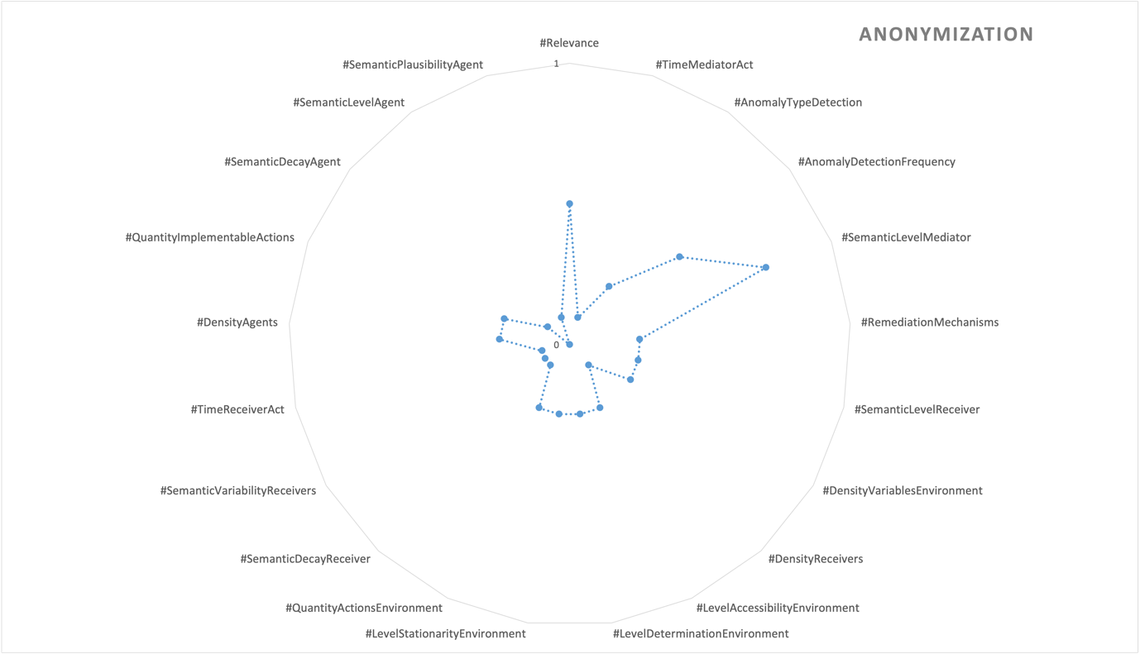

Annotation/Validation
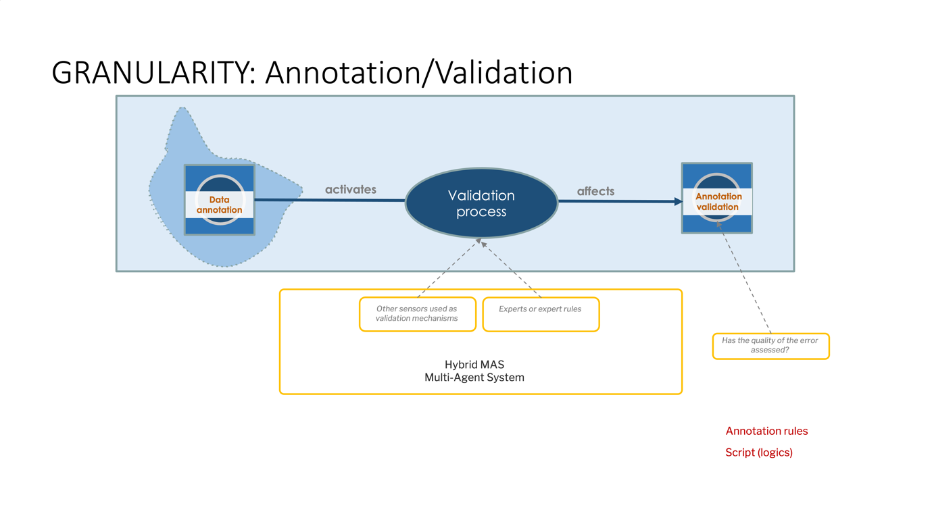
The annotation process of images involves labeling or tagging specific objects, regions, or features within the images to indicate specific objects, regions, or attributes of interest. This process helps in creating ground truth data for supervised learning. The use of other sensors, experts, or expert rules as validation mechanisms in the annotation process can be considered a multi-agent system. Each of these elements plays a role in verifying and validating the accuracy and quality of the annotations.
Ethically, the quality and semantic capability of the experts involved in the annotation process can have a significant impact. Experts with diverse backgrounds and expertise can introduce biases or subjective interpretations that may affect the consistency and reliability of the annotations. Biases in the annotation process can lead to biased training data, resulting in biased CNN models and potential unfair or discriminatory outcomes.

Mitigation strategies

An adapted strategy can be implemented.
- Diverse expert involvement. Engaging experts from diverse backgrounds can help mitigate biases and improve the overall quality and accuracy of the annotations..
- Clear annotation guidelines. This concerns the explainable AI (XAI) phase providing clear and explicit guidelines to the experts regarding the annotation criteria and expected standards can help minimise subjective interpretations and ensure consistency in the annotations.
- Regular quality control and audits. Implementing regular quality control measures, such as third parties independent audits and reviews, can help identify and address any biases or inconsistencies in the annotations. This process can also ensure adherence to established guidelines and improve the overall quality of the annotated dataset.
- Ongoing training and feedback. Providing continuous training and feedback to the experts involved in the annotation process can help improve their semantic capabilities and reduce potential biases. This can include workshops, educational resources, and open channels of communication to address any concerns or questions.

By implementing such mitigation strategies, the annotation process can strive for improved accuracy, fairness, and reliability, leading to high-quality training datasets and more ethically robust CNN models.

Assessment
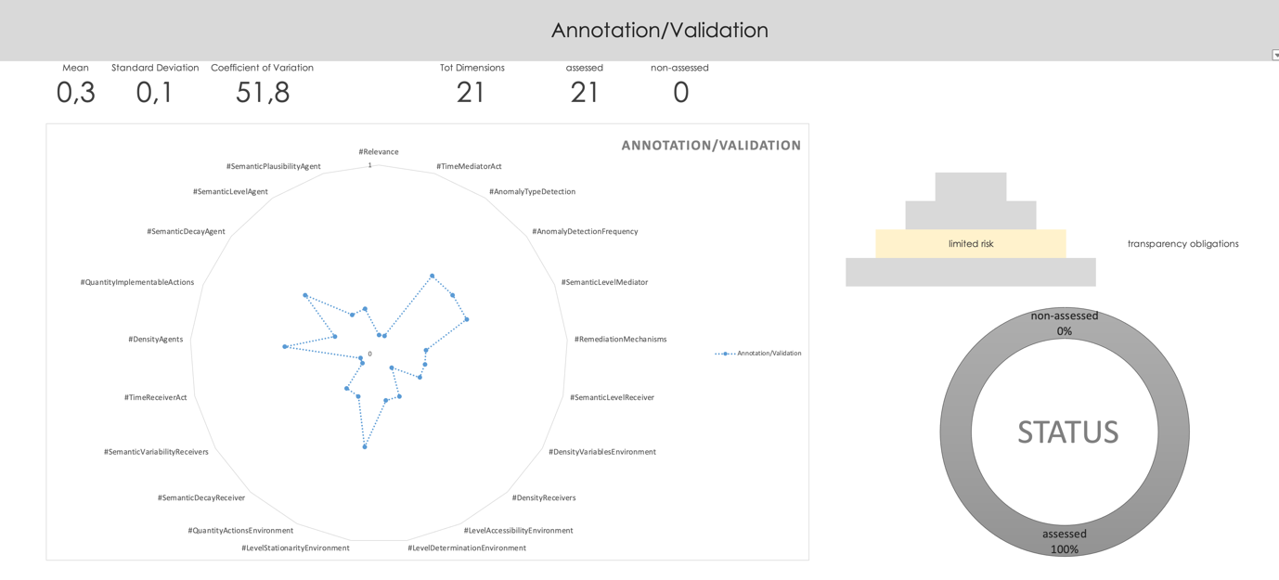
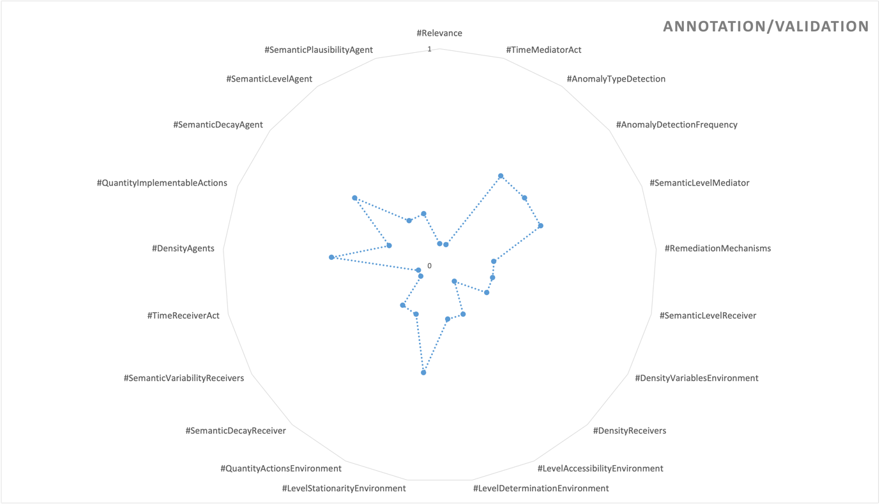

Data Versioning
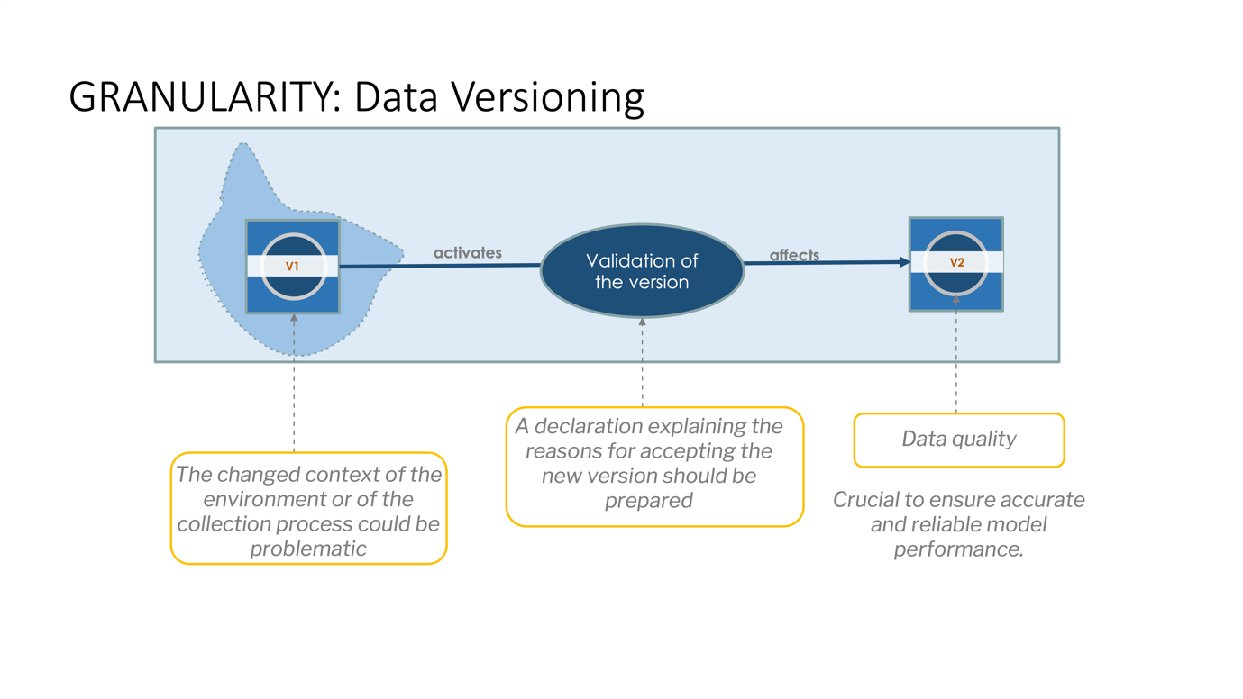
Data versioning refers to the practice of tracking and managing different versions of the data used for training and evaluating the AI model. It involves assigning unique identifiers or labels to different iterations or snapshots of the dataset, enabling easy reference and comparison between different versions.

Data versioning allows researchers, developers, and data scientists to keep track of changes made to the dataset over time. By maintaining a history of data versions, it becomes possible to reproduce and analyse the performance of the AI model at different stages of its development.

The benefits of data versioning include:
- Reproducibility. It ensures that the exact dataset used for a particular experiment or model training can be retrieved in the future. This enables the reproduction of experiments and the ability to compare results across different iterations.
- Error analysis and debugging. It allows practitioners to identify the specific dataset version that may have contributed to the problem, namely aiding in error analysis and debugging, helping to improve the model’s accuracy and reliability.
- Regulatory compliance: Data versioning can be crucial for maintaining compliance with regulations and standards. It enables the traceability of data used in the AI system, ensuring accountability and facilitating audits or investigations if required. In fact, it could be a part of “logging systems”.

New versions of the dataset may embed environmental drift, namely changes in the conditions or context in which the AI model should operates.
Environmental drift shares similarities with data shift and model shift, but it specifically pertains to changes in the real world, such as the introduction of new road signs or elements that impact the driving environment.
It can impact the AI model’s performance by introducing new sources of uncertainty or changing the dynamics of the problem space. To account for environmental drift, the AI system should be designed to adapt to different operating conditions or undergo continuous monitoring and updates to ensure robustness.

Mitigation strategies
Mitigation strategies to reduce ethical risks associated with environmental drift include:

- Continuous monitoring. Implementing a system to continuously monitor the performance and behaviour of the AI system in different operating conditions. This allows for early detection of environmental drift and facilitates timely interventions.
- Real-time adaptation: Designing the AI system with the capability to adapt and adjust its behaviour in response to changing environmental conditions. This can involve dynamic decision-making algorithms that can optimise performance in varying situations.
- Ethical impact assessments. Conducting ethical impact assessments and ethical foresight analysis to identify and address any potential ethical implications resulting from the AI system’s response to environmental drift. This includes considering fairness, safety, privacy, and other ethical concerns.

Assessment

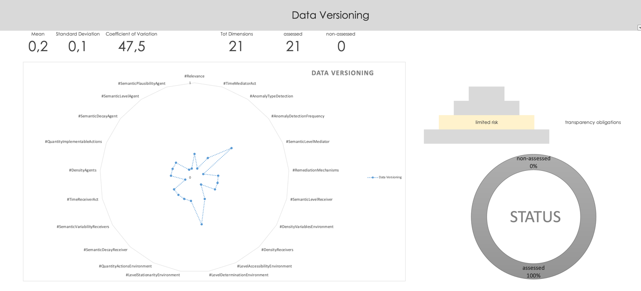
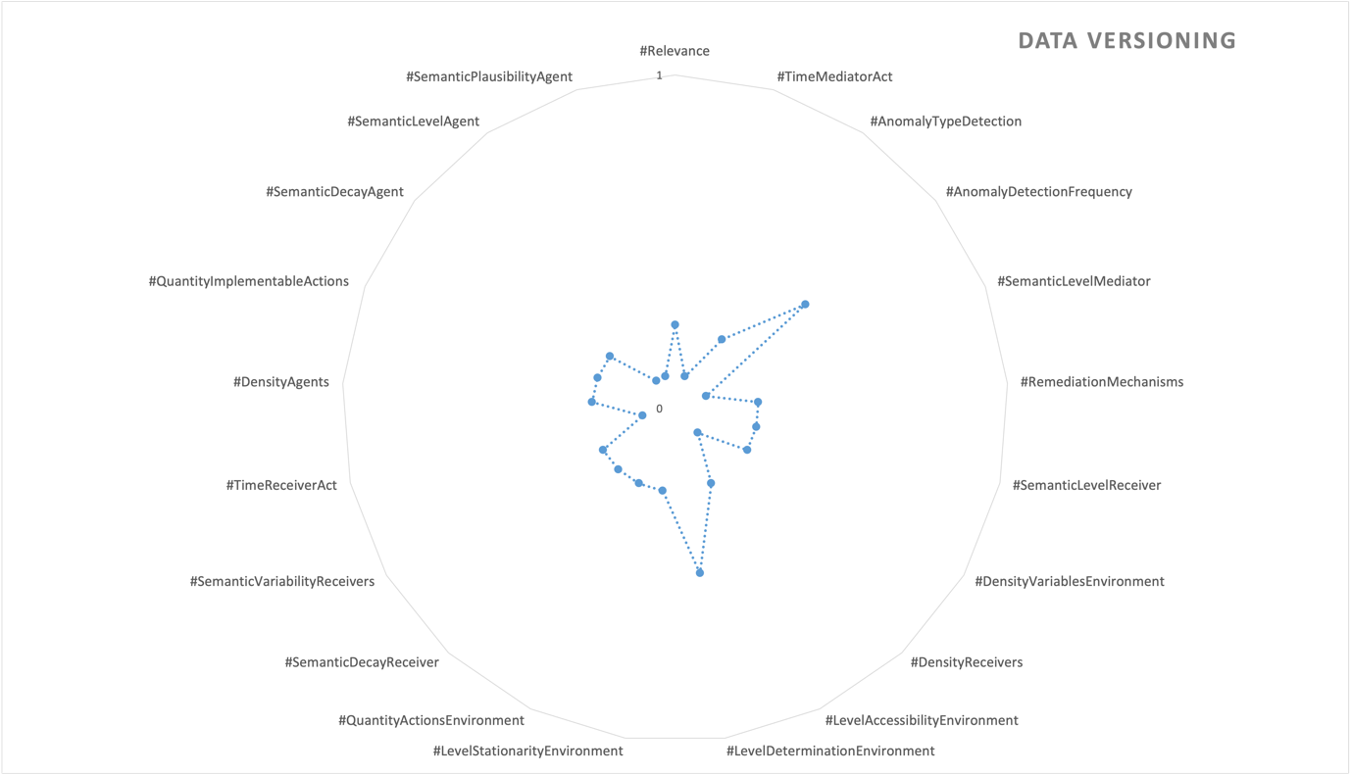

Data Split
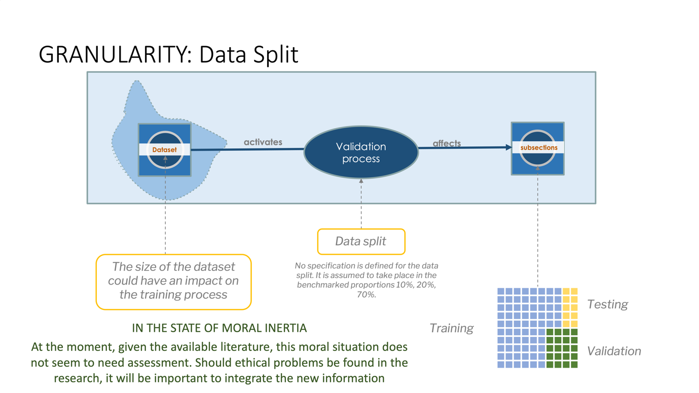
In an AI perception system for autonomous parking, a data split refers to the division of available data into distinct subsets for training, validation, and testing purposes. The purpose of data splitting is to assess and optimise the performance of the AI model accurately.
Typically, the data split involves the following subsets:
- Training set. This subset constitutes the largest portion of the data and is used to train the AI model.
- Validation set. A smaller portion of the data is reserved for the validation set.
- Testing set. This subset is completely independent of the training and validation sets.

It’s important to note that the sise of each subset may vary depending on the available data and the specific requirements of the AI perception system.

Threshold of moral negligibility
The “threshold of moral negligibility” refers to the point at which the moral significance or impact of a particular action or consequence is considered to be so minor or insignificant that it does not warrant significant moral concern or ethical scrutiny.

At the moment, given the available literature, this moral situation does not seem to need assessment. Should ethical problems be found in the research, it will be important to integrate the new information

Assessment
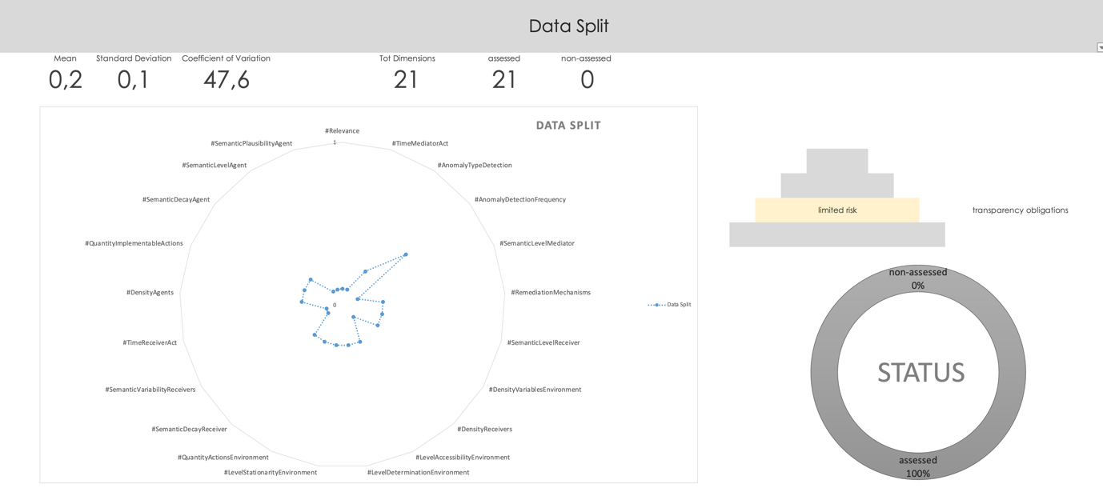
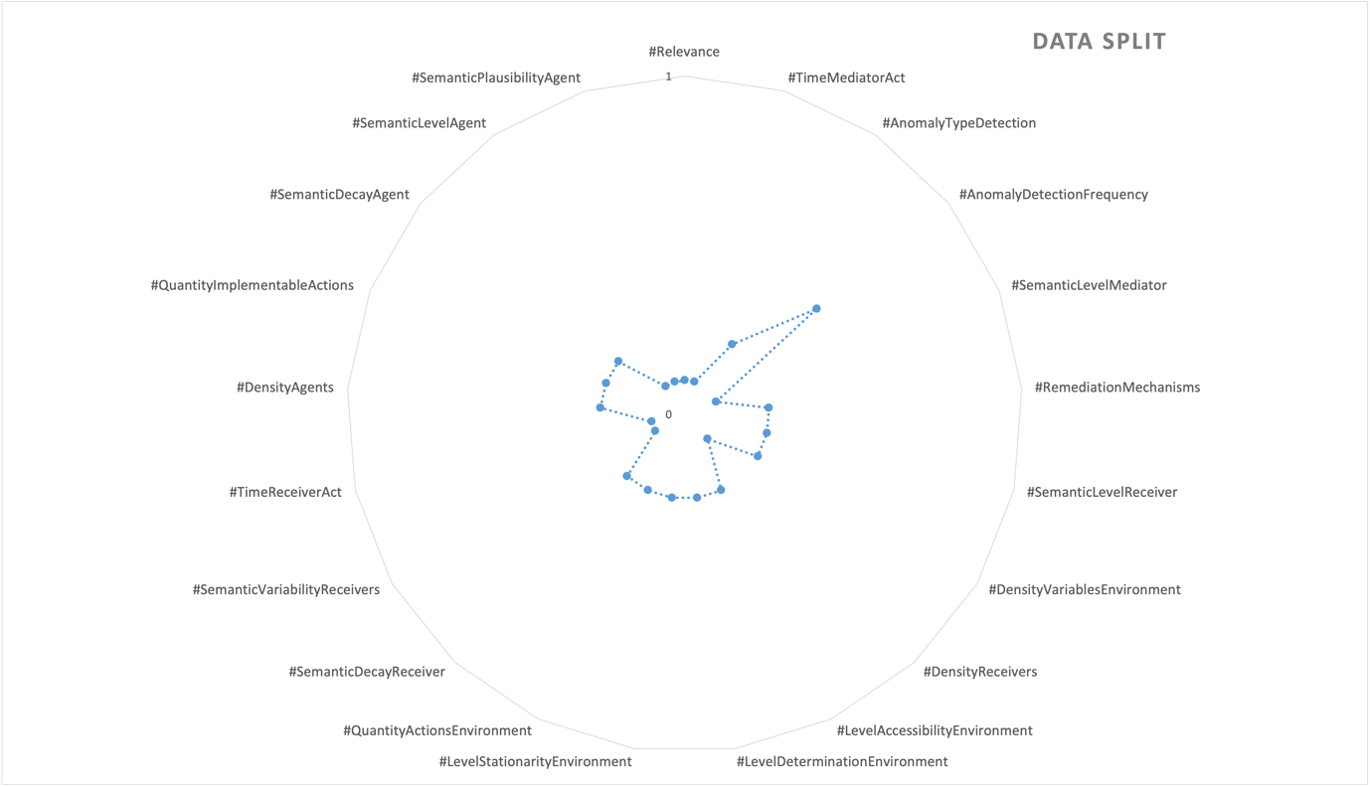

CNN
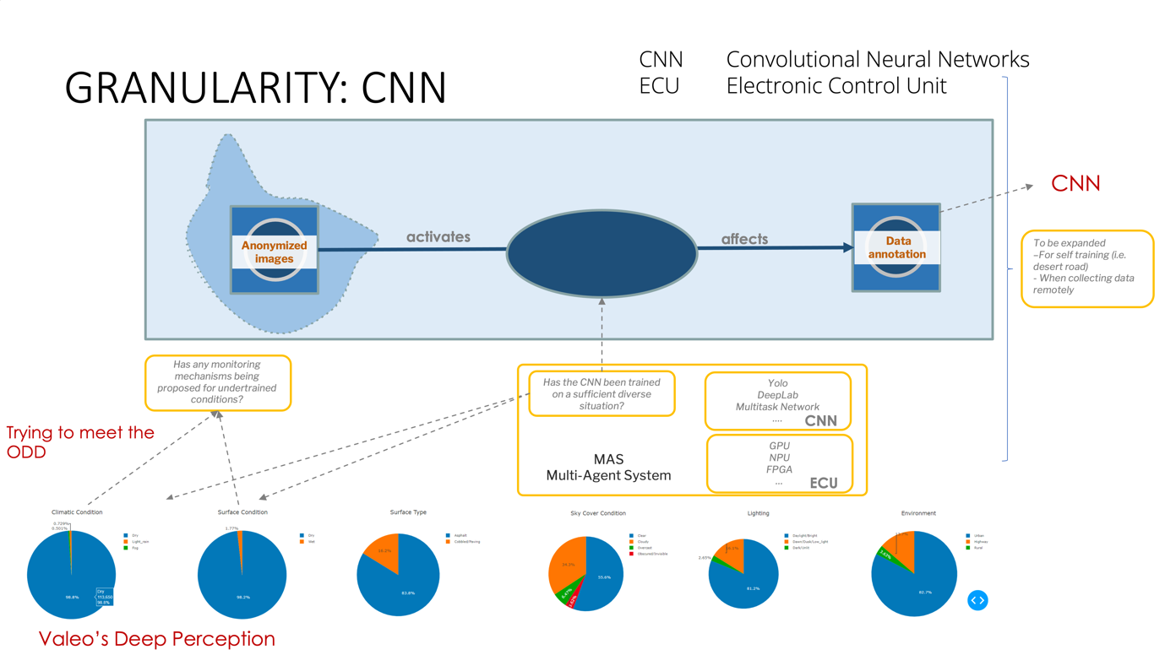

The Convolutional Neural Network (CNN) for cameras we analysed is an integral component of an Electronic Control Unit (ECU) in the autonomous car system, providing advanced visual perception capabilities. In the specific use case mentioned, the CNN is trained solely offline and in a limited environment. However, if the CNN were to be trained online, potential future ethical risks could arise

Mitigation strategies
Mitigation strategies include :

- Safety concerns. If the CNN lacks robustness or encounters unforeseen situations during real-time operation, extensive testing, validation, and safety measures, including fail-safe mechanisms, to ensure the CNN’s reliability and responsiveness.
- Privacy and data protection. The collection and processing of real-time data may raise privacy concerns, then implementing strong data protection protocols, and anonymizing or aggregating data to safeguard individuals’ privacy should be considered.
- Explainability. If it may become difficult to understand how the CNN reaches its decisions, then techniques for explainable AI, should be improved.
- Adversarial attacks. The CNN may become vulnerable to adversarial attacks, where malicious actors manipulate input data to deceive or compromise the system’s functionality. In this case, robust security measures, anomaly detection algorithms, and adversarial training to enhance the CNN’s resilience against such attacks.

Assessment
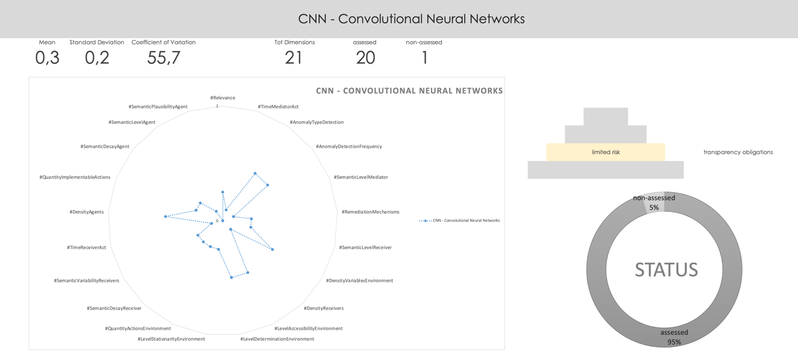

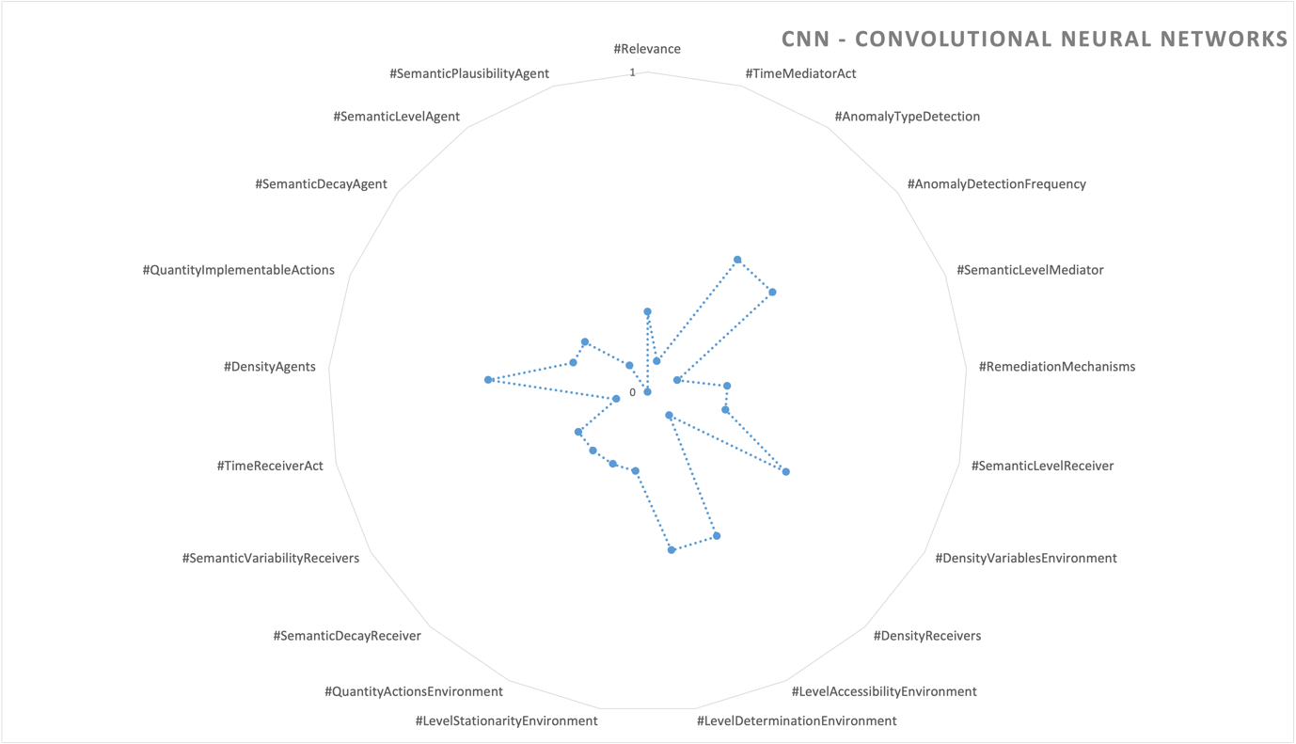

Interpreting the surroundings
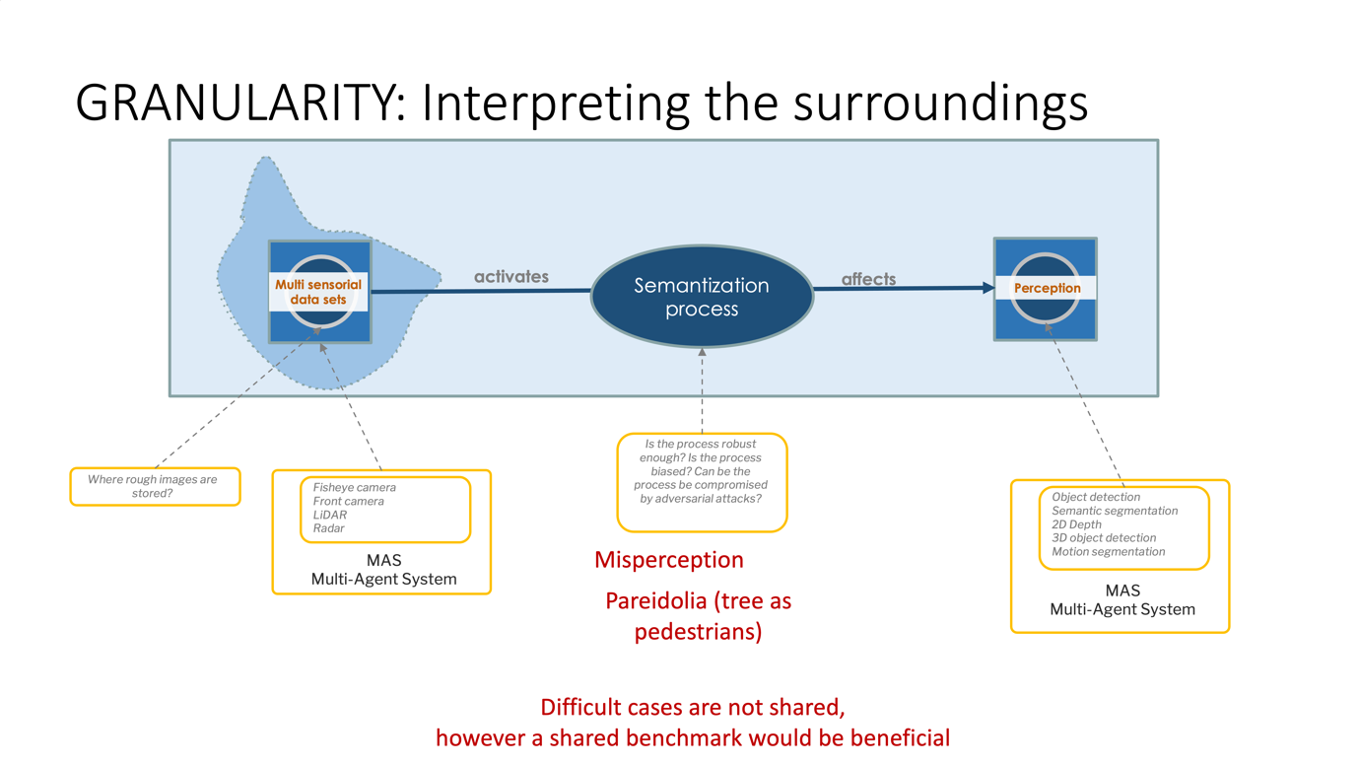
Interpreting the surroundings involves analyzing sensor data and making sense of the environment to understand objects, road conditions, and other relevant factors. Possible semantical risks in interpreting the surroundings include misclassifications, inaccurate object recognition, and misinterpretations of complex scenarios. As an example, the pareidolia effect (the tendency to perceive meaningful patterns or objects in random or ambiguous stimuli) can potentially lead to misinterpretations in parking an autonomous car, such as mistaking trees for pedestrians, impacting the car’s decision-making process and potentially compromising safety.

Mitigation strategies
Mitigation strategies to reduce ethical risks in autonomous car systems include:

- Transparent and explainable AI. Developing deep learning models that are interpretable and transparent, enabling better understanding and accountability of the decision-making process.
- Diverse and representative training data. Ensuring the training data used for developing the AI models encompasses a wide range of demographics, scenarios, and environmental conditions to mitigate biases and promote fairness, as seen in the ‘datafication process’.
- Continuous monitoring and evaluation. Conducting regular performance evaluations of the AI system to detect and address potential biases, errors, or unintended consequences, ensuring ongoing compliance with ethical standards.
- Fail-safe mechanisms and fallback strategies. Implementing fail-safe mechanisms and backup plans to mitigate risks and ensure safe operation in critical situations, such as emergency stops or human intervention capabilities.
- Stakeholder engagement. Involving diverse stakeholders, including the public or other automotive companies, in discussions and decision-making processes related to autonomous car systems to ensure transparency, accountability, and public trust.
- Regular audits and reviews. Conducting third parties independent audits and reviews of the AI system’s behavior, data practices, and decision-making to identify and address any ethical risks or concerns.

Assessment
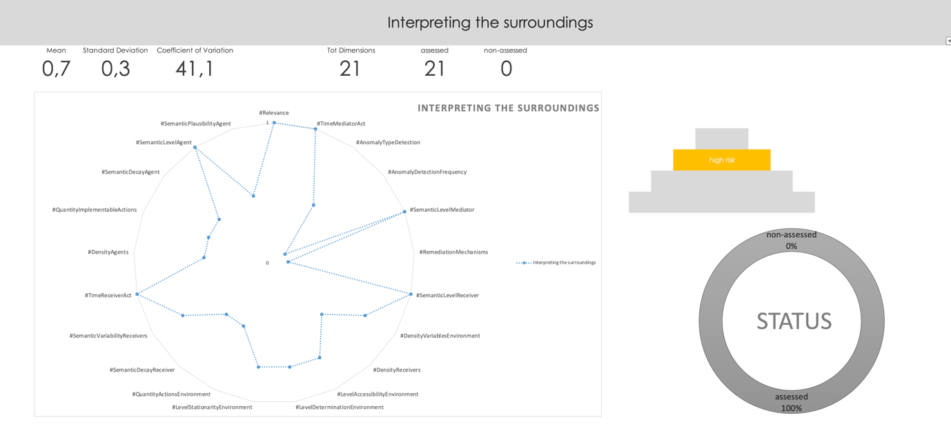

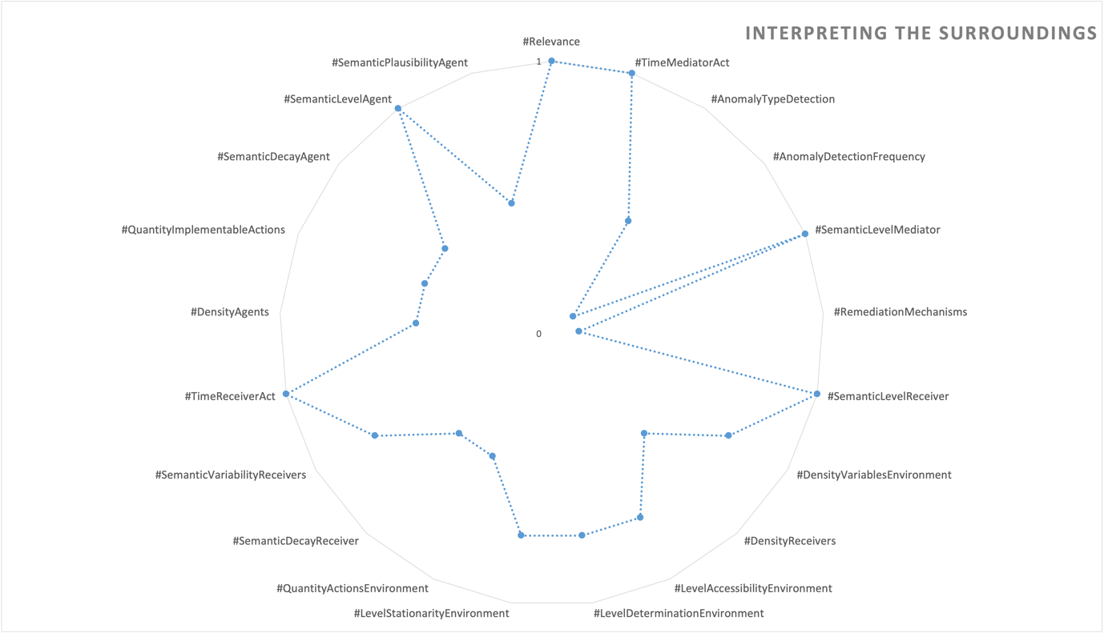

Decision process & Path Trajectory
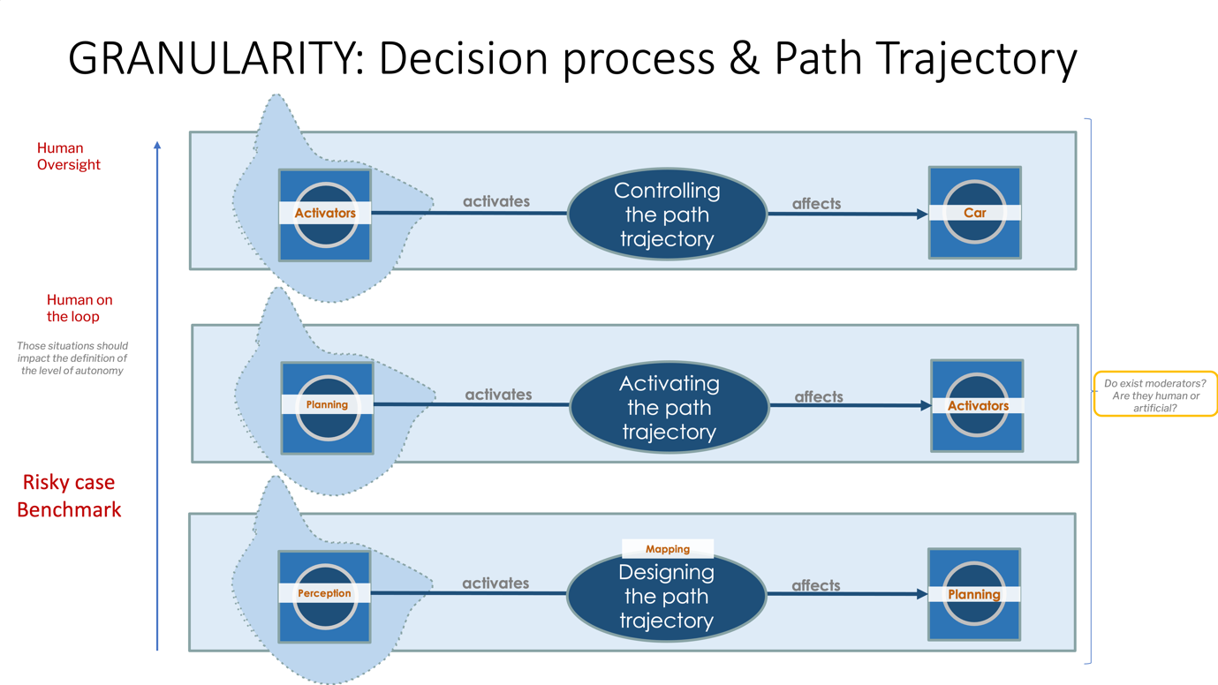

In this use case, the path trajectory refers to the planned route or path that the vehicle follows during the parking maneuver, taking into account factors such as available space, obstacles, and alignment with parking spots.

The path trajectory in parking an autonomous car involves three phases:

- Designing the path trajectory: In this phase, the perception of the car’s surroundings is transformed into a planned path trajectory. The perception data is processed and analyzed by the planning module to determine the optimal path for parking.
- Activating the path trajectory: Once the path trajectory is developed, it is transformed into a decision by the planning module. This decision includes instructions on how the car should navigate and position itself during the parking process. The decision is then passed on to the activators or actuators, which are responsible for physically controlling the car’s movements.
- Controlling the path trajectory: In this final phase, the activators, in coordination with other systems, execute the planned path trajectory. The activators control the car’s steering, acceleration, and braking to accurately maneuver and park the vehicle within the designated parking space.

Overall, the path trajectory in parking an autonomous car involves the transformation of perception into planning, activation of the planned trajectory, and subsequent control of the car’s movements to accomplish the parking process.

Level of autonomy
The moral situations that arise during the path trajectory in autonomous car systems can have a significant influence on determining the appropriate level of autonomy, as shown in Figure 8. These situations, which involve ethical considerations and decision-making, can shape the boundaries and limitations of autonomy, influencing whether human intervention or oversight is required in certain circumstances. The main three type of intervention can be:

- Human Oversight is the higher-level monitoring and supervision of an autonomous system. It involves humans overseeing the system’s behavior, analyzing its outputs, and making strategic decisions or interventions when necessary. Human oversight provides a broader perspective and is typically conducted from a more distant standpoint, without direct real-time involvement in the system’s operations. In the future, it is possible that live Human Oversighting could be provided as a service.
- Human on the Loop is a level of human involvement where individuals are actively engaged in monitoring and controlling the autonomous system. They play a role in supervising the system’s actions, providing inputs, and making decisions based on the system’s outputs. Human on the loop allows humans to step in and take control when needed, but the system largely operates autonomously for extended periods.
- Human in the Loop is a higher degree of human participation and direct interaction with the autonomous system. Humans are continuously involved in the system’s operation, providing inputs, monitoring its performance, and actively influencing decision-making processes. Human in the loop systems rely heavily on human input and oversight to ensure accuracy, reliability, and ethical decision-making.

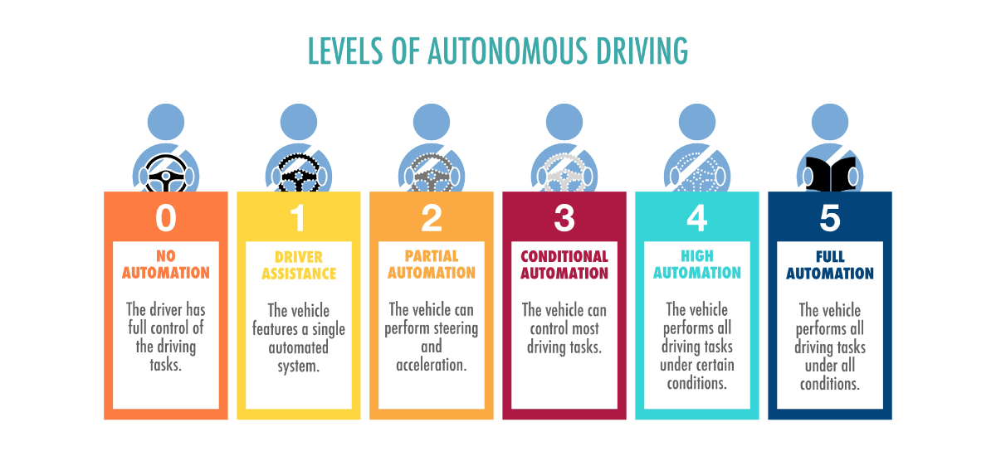
Figure 8 - Car autonomy level

Mitigation strategies
Adapted mitigation strategies for possible ethical risks in parking autonomous cars include:
- Safety-first approach. Prioritizing safety in the parking process by ensuring collision avoidance, pedestrian detection.
- Intelligible communication: Implementing clear visual or auditory signals to inform pedestrians and nearby drivers about the autonomous car’s intentions during parking maneuvers.
- Sensory redundancy. Already in use. Utilizing multiple sensors and redundancy mechanisms to enhance perception and reduce the risk of false detections or misinterpretations.
- Continuous monitoring and improvement. Conducting regular monitoring and evaluation of the parking system’s performance, analyzing potential ethical risks, and actively seeking ways to improve its accuracy, fairness, and safety.
- Risky case benchmark. Conducting comprehensive benchmarking to identify and assess potential risky cases or edge scenarios that the autonomous car may encounter during the path trajectory, ensuring the system’s robustness and safety in challenging situations.
- Logging mechanism. Recording and storing relevant data and events generated by autonomous systems for monitoring, analysis, and debugging purposes.

Assessment
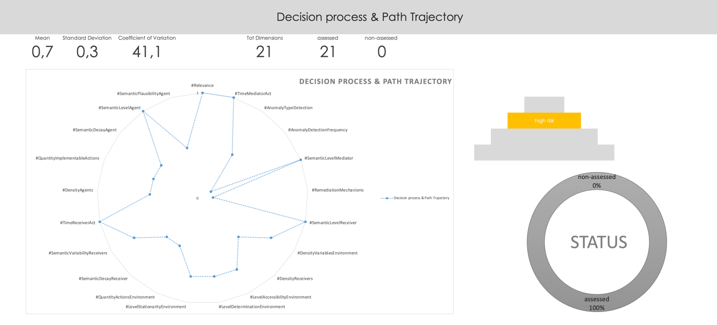

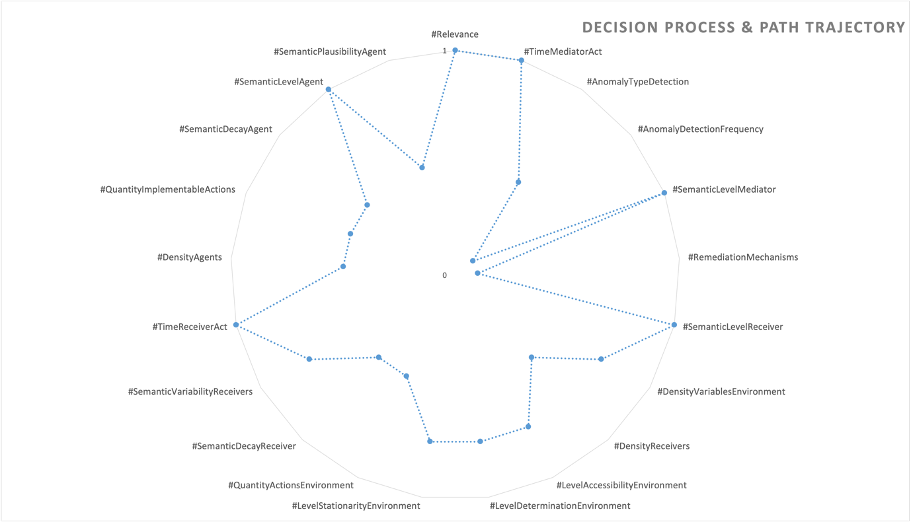

Liability level

The legislative direction suggests the potential adoption of ‘strict liability’ principles for all suppliers and assemblers of autonomous systems, meaning that in case of an accident, the entire supply chain would initially share the same level of liability. Moreover, due to existing legislative uncertainty, an increase in lawsuits is anticipated. To mitigate moral responsibility, demonstrating comprehensive ‘assurance’ through ethical assessments and analyses will become crucial.

Further investigation and collaboration with other industries are necessary to explore and understand this level more comprehensively.

Annexes

Axiological analysis

A series of open-ended questions helps to elicit the identification of the risks posed by this use case. These risks are grouped into several dimensions, referring directly to the informational entities that constitute the moral situation.
An axiological analysis can be conducted for every situation, involving the examination and evaluation of the values at play and their ethical implications.

An axiological analysis is a philosophical and ethical examination that focuses on the study of values, including moral values and principles. It involves assessing and evaluating the inherent worth, significance, and ethical implications of various beliefs, actions, and systems based on their alignment with certain values or value systems. Axiological analysis aims to explore the underlying values and their implications to provide insights into ethical decision-making, moral frameworks, and the overall evaluation of ideas, behaviors, or phenomena in terms of their value-based significance.

In this phase, an axiological analysis assigns a numerical value to a 5-point Likert scale for each dimension. The numerical values are not fixed once and for all but can be ‘tuned’ within the organization to adhere more closely to the particular application under consideration. Likert scale includes descriptive words that are easily understandable by developers. The ethical risk assessment is per-formed, which consists of selecting the right Likert option for each dimension to determine an overall risk level. Finally, a visualization of the risk in the form of a radar chart makes it possible to assess the overall risk level in relation to the risk level of the individual dimensions, facilitating the interplay between a holistic and an analytical perspective.

Driving space
Dimension | Driving space
Relevance | nuisances
TimeMediatorAct | minutes
AnomalyTypeDetection | Known unknown (narrow range)
AnomalyDetectionFrequency | live detection
SemanticLevelMediator | human
RemediationMechanisms | as soon as possible
SemanticLevelReceiver | adv beginner
DensityVariablesEnvironment | fifty/fifty
DensityReceivers | single person
LevelAccessibilityEnvironment | fifty/fifty
LevelDeterminationEnvironment | Hybrid
LevelStationarityEnvironment | Slight impact on the environment
QuantityActionsEnvironment | a moderate number of actions
SemanticDecayReceiver | Normalised semantic change
SemanticVariabilityReceivers | Social semantics
TimeReceiverAct | minutes
DensityAgents | Monolitic multigent
QuantityImplementableActions | Few actions
SemanticDecayAgent | Slight semantic change
SemanticLevelAgent | AI
SemanticPlausibilityAgent | Behavioural imitation

Datafication process
Dimension | Datafication process
Relevance | nuisances
TimeMediatorAct | months
AnomalyTypeDetection | Known unknown (narrow range)
AnomalyDetectionFrequency | long period detection
SemanticLevelMediator
RemediationMechanisms | in regular basis
SemanticLevelReceiver | proficient
DensityVariablesEnvironment | more known variables
DensityReceivers | no human involved
LevelAccessibilityEnvironment | more known variables
LevelDeterminationEnvironment | With some non-deterministic consequences
LevelStationarityEnvironment | Hybrid
QuantityActionsEnvironment | a limited number of actions
SemanticDecayReceiver | Slight semantic change
SemanticVariabilityReceivers | Semantic community
TimeReceiverAct | no time
DensityAgents | Single agent
QuantityImplementableActions | Few actions
SemanticDecayAgent | Semantic preservation
SemanticLevelAgent | expert system
SemanticPlausibilityAgent | No imitation (AI is clearly recognisable)

Anonymization
Dimension | Anonymization
Relevance | financial dignity
TimeMediatorAct | months
AnomalyTypeDetection | Known unknown (wide range)
AnomalyDetectionFrequency | short period detection
SemanticLevelMediator | expert system
RemediationMechanisms | as soon as possible
SemanticLevelReceiver | proficient
DensityVariablesEnvironment | more known variables
DensityReceivers | no human involved
LevelAccessibilityEnvironment | more known variables
LevelDeterminationEnvironment | With some non-deterministic consequences
LevelStationarityEnvironment | Slight impact on the environment
QuantityActionsEnvironment | a limited number of actions
SemanticDecayReceiver | Semantic preservation
SemanticVariabilityReceivers | Narrow and uniform semantics
TimeReceiverAct | months
DensityAgents | Single agent
QuantityImplementableActions | Few actions
SemanticDecayAgent | Semantic preservation
SemanticLevelAgent
SemanticPlausibilityAgent | No imitation (AI is clearly recognisable)

Annotation/Validation
Dimension | Annotation/Validation
Relevance | none
TimeMediatorAct | months
AnomalyTypeDetection | Known unknown (narrow range)
AnomalyDetectionFrequency | short period detection
SemanticLevelMediator | human
RemediationMechanisms | as soon as possible
SemanticLevelReceiver | proficient
DensityVariablesEnvironment | more known variables
DensityReceivers | no human involved
LevelAccessibilityEnvironment | more known variables
LevelDeterminationEnvironment | With some non-deterministic consequences
LevelStationarityEnvironment | Hybrid
QuantityActionsEnvironment | a limited number of actions
SemanticDecayReceiver | Slight semantic change
SemanticVariabilityReceivers | Narrow and uniform semantics
TimeReceiverAct | months
DensityAgents | Monolitic multigent
QuantityImplementableActions | Few actions
SemanticDecayAgent | Normalised semantic change
SemanticLevelAgent | aware human in the process
SemanticPlausibilityAgent | Lingustic imitation

Data Versioning
Dimension | Data Versioning
Relevance | nuisances
TimeMediatorAct | months
AnomalyTypeDetection | Known unknown (wide range)
AnomalyDetectionFrequency | short period detection
SemanticLevelMediator | expert human in the process
RemediationMechanisms | as soon as possible
SemanticLevelReceiver | proficient
DensityVariablesEnvironment | more known variables
DensityReceivers | no human involved
LevelAccessibilityEnvironment | more known variables
LevelDeterminationEnvironment | Hybrid
LevelStationarityEnvironment | Slight impact on the environment
QuantityActionsEnvironment | a limited number of actions
SemanticDecayReceiver | Slight semantic change
SemanticVariabilityReceivers | Semantic community
TimeReceiverAct | months
DensityAgents | Single agent
QuantityImplementableActions | Few actions
SemanticDecayAgent | Slight semantic change
SemanticLevelAgent | expert human in the process
SemanticPlausibilityAgent | No imitation (AI is clearly recognisable)

Data Split
Dimension | Data Split
Relevance | none
TimeMediatorAct | months
AnomalyTypeDetection | Known unknown (wide range)
AnomalyDetectionFrequency | short period detection
SemanticLevelMediator | expert human in the process
RemediationMechanisms | as soon as possible
SemanticLevelReceiver | proficient
DensityVariablesEnvironment | more known variables
DensityReceivers | no human involved
LevelAccessibilityEnvironment | more known variables
LevelDeterminationEnvironment | With some non-deterministic consequences
LevelStationarityEnvironment | Slight impact on the environment
QuantityActionsEnvironment | a limited number of actions
SemanticDecayReceiver | Slight semantic change
SemanticVariabilityReceivers | Narrow and uniform semantics
TimeReceiverAct | months
DensityAgents | Single agent
QuantityImplementableActions | Few actions
SemanticDecayAgent | Slight semantic change
SemanticLevelAgent | expert human in the process
SemanticPlausibilityAgent | No imitation (AI is clearly recognisable)

CNN - Convolutional Neural Networks

Dimension | CNN - Convolutional Neural Networks
Relevance | nuisances
TimeMediatorAct | months
AnomalyTypeDetection | Known unknown (narrow range)
AnomalyDetectionFrequency | short period detection
SemanticLevelMediator | expert human in the process
RemediationMechanisms | as soon as possible
SemanticLevelReceiver | proficient
DensityVariablesEnvironment | fifty/fifty
DensityReceivers | no human involved
LevelAccessibilityEnvironment | fifty/fifty
LevelDeterminationEnvironment | Hybrid
LevelStationarityEnvironment | Slight impact on the environment
QuantityActionsEnvironment | a limited number of actions
SemanticDecayReceiver | Slight semantic change
SemanticVariabilityReceivers | Semantic community
TimeReceiverAct | months
DensityAgents | Monolitic multigent
QuantityImplementableActions | Few actions
SemanticDecayAgent | Slight semantic change
SemanticLevelAgent | expert human in the process
SemanticPlausibilityAgent

Interpreting the surroundings

Dimension | Interpreting the surroundings
Relevance | vital
TimeMediatorAct | no time
AnomalyTypeDetection | Known unknown (narrow range)
AnomalyDetectionFrequency | live detection
SemanticLevelMediator | AI
RemediationMechanisms | just in time
SemanticLevelReceiver | inexperienced
DensityVariablesEnvironment | more unknown variables
DensityReceivers | small subgroup (i.e. family)
LevelAccessibilityEnvironment | more unknown variables
LevelDeterminationEnvironment | With many non-deterministic consequences
LevelStationarityEnvironment | High impact on the environment
QuantityActionsEnvironment | a moderate number of actions
SemanticDecayReceiver | Normalised semantic change
SemanticVariabilityReceivers | Social semantics
TimeReceiverAct | no time
DensityAgents | Monolitic multigent
QuantityImplementableActions | Average number of actions for system
SemanticDecayAgent | Normalised semantic change
SemanticLevelAgent | AI
SemanticPlausibilityAgent | Behavioural imitation

Decision process & Path Trajectory

Dimension | Decision process & Path Trajectory
Relevance | vital
TimeMediatorAct | no time
AnomalyTypeDetection | Known unknown (narrow range)
AnomalyDetectionFrequency | live detection
SemanticLevelMediator | AI
RemediationMechanisms | just in time
SemanticLevelReceiver | inexperienced
DensityVariablesEnvironment | more unknown variables
DensityReceivers | small subgroup (i.e. family)
LevelAccessibilityEnvironment | more unknown variables
LevelDeterminationEnvironment | With many non-deterministic consequences
LevelStationarityEnvironment | High impact on the environment
QuantityActionsEnvironment | a moderate number of actions
SemanticDecayReceiver | Normalised semantic change
SemanticVariabilityReceivers | Social semantics
TimeReceiverAct | no time
DensityAgents | Monolitic multigent
QuantityImplementableActions | Average number of actions for system
SemanticDecayAgent | Normalised semantic change
SemanticLevelAgent | AI
SemanticPlausibilityAgent | Behavioural imitation

